How Digital Leadership competences and IT Capabilities affect an organization's ability to digitally transform and
adopt new technologies

Melissa Brunner¹
Gabriel Gonzalez-Castañé¹
Pascal Ravesteijn²

¹Insight - SFI Research Centre for Data Analytics, University College Cork
²HU University of Applied Sciences

ABSTRACT

Although much research has been done into the importance of IT Capabilities (ITC), Digital Leadership (DL) and Digital Transformation (DT) with regard to organizations’ firm performance and ability to thrive in the current digital market, there is little research on qualifying which specific ITC and DL competences affect the success of an organization's DT and ultimately impact their ability to adopt newly emerging technologies. This research aims to address the influence of DL and ITC on DT as well as which specific DL competences and ITC might ultimately affect an organization’s ability to successfully adopt newly emerging digital technologies. Quantitative data collected through a survey was used for this analysis. It was found that Architecture Design (DLA5) has the strongest positive affect on DT.

Keywords: IT Capabilities • Digital Leadership • Digital Transformation • e-Competence Framework

INTRODUCTION

The availability of enormous computing capacity has facilitated merging the physical, digital and biological worlds today (Saldanha, 2019) leading to the Fourth Industrial Revolution of the twenty first century. This Industrial Revolution is heavily characterized by Digital Transformation (DT) (Chou, 2019). With an increased and fast-paced DT in enterprises and their environment, such as a shift to big data, increased usage of mobile and social media platforms, cloud computing and new improved analytics, existing business models are disrupted, and positive business changes, such as a decrease in costs, and new opportunities are introduced (Nwankpa & Roumani, 2016). Nonetheless, along with ample opportunities, this new digital environment with technologies such as the Internet of Things (IoT),
Artificial Intelligence, cloud and blockchain also poses new challenges (Chou, 2019). The constant emergence and development of new technologies that are creating a ceaselessly competitive environment for businesses is of great importance for companies to be able to ensure that they have the relevant technologies at their disposal. However, solely possessing a technology is not sufficient for gaining maximum benefits. Therefore, it is necessary to find a mechanism that allows companies to evolve and embrace new technologies.
One of the capabilities associated with DT that may have an impact on a company’s ability to adapt new technologies is Digital Leadership (DL). Prentice (1961, p.143) defined leadership as “the ability to accomplish a goal through the direction of human assistants.” Aligned with this definition of leadership, Digital Leadership, which can also be referred to as e-leadership, has been defined by Hüsing et al. (2013, p.13) as “the accomplishment of a goal that relies on ICT through the direction of human resources and uses of ICT.”
It has been observed that organizations lacking DL competences have failed to exploit the full potential of technologies (Boomer, 2019). The main reason for failing (almost 70 percent) is due to inadequately defining and executing the correct steps to DT (Saldanha, 2019). It is key for companies to prepare for digital technologies and to ensure enough capabilities to manage these efficiently at company level (Kane et al., 2018). In this context capabilities can be considered strategically applying, deploying, renewing, extending, modifying and changing resources - organisational and individual - to ensure the organization’s effectiveness and competitiveness (Mikalef et al., 2019).

A mechanism to enable adoption of new digital technologies has been proven to be the use of DL Competences and IT Capabilities (ITC). These, as the combination of managerial, technical and proactive competences, are an enabler of performance that can be used for improving DT (Nwankpa & Roumani 2016; Ravesteijn and Ongena, 2019). However, a refined study is needed to have an efficient applicability of DL and ITC, yet it is challenging to have an efficient methodology as none of
these works focus on individual ITC and DL competences for companies as enablers of Digital Transformation.
This paper focuses on the relationship between Digital Leadership competences and IT Capabilities as enablers for industrial Digital Transformation.
The key contribution is to find the competences and their impact - for both individuals and companies – to enable a successful Digital Transformation of organizations, allowing a successful exploitation of emergent technologies that position them ahead of their competitors.
The ITC and competences of DL are classified through a conceptual model – Section 3, Figure 1 -, and analysed on 433 individuals belonging to an industrial audience – SMEs, Midcaps, Start-ups and industry at large – Section 4. Furthermore, a statistical analysis to validate the results has been carried out and is described in Section 5.

RELATED WORK
Digital technologies are constantly evolving and new digital technologies continuously emerging. Within the context of the Fourth Industrial Revolution, the definition of Digital Transformation is considered the migration of enterprises and societies from the Third Industrial Revolution, which was characterized by technologies such as PCs and the internet, to the Fourth Industrial Revolution where digital technologies such as Artificial Intelligence and cloud become the base of new products and services, of new ways of operating and of new business models (Saldanha, 2019; Chou, 2019). In this rapidly changing digital environment IT-based tools such as digital technologies can benefit companies by aiding them in remaining agile, enhancing their response capabilities and by facilitating processes (Chakravarty, 2013). In line with the Fourth Industrial Revolution, from an organizational perspective DT could be considered deeply transforming models, processes, competencies and activities in order to facilitate the adaptation of digital technologies and thereby enable change and exploit new opportunities (Moreira et al., 2018).

Based on this definition DT can be defined as the process of adapting capabilities, processes and values to accommodate new technologies as well as the process of adopting new technologies themselves. Therefore, despite DT often only being associated with changing products and services based on technologies, it is also crucial to consider changes in the organizational architecture (Venkatraman, 2017). In addition to updating the supporting Information Systems and aligning these with new technologies (Moreira et al., 2018), it is thus also important to ensure that existing facilities and services, including individual and organizational competences, are not neglected but rather adapted to compliment new technologies (Davenport & Westerman, 2018). Developing both the necessary physical infrastructure as well as the necessary institutional infrastructure to adopt and exploit digital technologies is therefore an important component of DT. IT Capabilities are fundamental in developing these infrastructures and according to Lu and Ramamurthy (2011) consist of the dimensions IT infrastructure capability, IT business spanning capability and IT proactive stance. The aforementioned processes involved in DT highlight the need for identifying individual competences and capabilities necessary for enabling DT by transforming models, processes and activities.
With respect to the Digital Leadership competences, the European Committee for Standardization (CEN) have published the European e-Competence Framework (eCF) in a Workshop Agreement (CWA) which aims to facilitate the definition of individual digital competences and thus provide value to organizations (CWA 164581:2018 (E), 2018, p. 33). The e-CF describes different roles within the IT profession and the Digital Transformation Leader Role (DTLR) and corresponding competences fit the definition of DL as stated above. Ravesteijn and Ongena (2019) have found that the e-CF competences of the DTLR has a significant positive relationship with DT. The competences of the DTLR can therefore be considered fundamental to this study. The competences required for the DTLR are Business Plan Development (A3)1, Architecture Design (A5), Innovating (A9), Business Change Management (E7) and IS Governance (E9) (CWA 16458-1:2018 (E), 2018, p. 33; Ravesteijn and Ongena, 2019).

1 Codes between brackets are the identifiers of a specific competence within the e-CF framework

The research presented in this study is part of broader research on the relationship between DL competences and an organization’s ITC and DT readiness. Fundamental research by Nwankpa and Roumani (2016) on the mediating roles of DT in the relationship between firm performance and ITC as well as research by Ravesteijn & Ongena (2019) on the role of e-leadership in relation to ITC and DT provide a foundation for this research. Moreover, Nwankpa and Roumani’s (2016) measures for ITC, i.e. IT Infrastructure, IT Business Spanning and IT Proactive Stance have been adopted in this study.
The measures for DT, i.e. driving new business processes built on technologies, integrating digital technologies and shifting towards making use of digital technologies, as well as the measures for DL that were used by Ravesteijn & Ongena (2019), have also been adopted in this study. However, while these studies focused on the general concepts of DL, ITC and DT, this study provides a valuable insight to individual ITC and DL competences that enable DT.

CONCEPTUAL MODEL FOR RESEARCH
The conceptual model presented in this paper is depicted in Figure 1. It consists of three main constructs – the ovals in Figure 1: DL, DT and ICT – to further examine findings in the literature with respect to the positive impact that DL and ITC have on DT; and eight sub-construct – Rectangles – used to examine which individual
DL competences and ITC have a more significant impact on DT.

Figure 1 - Conceptual model
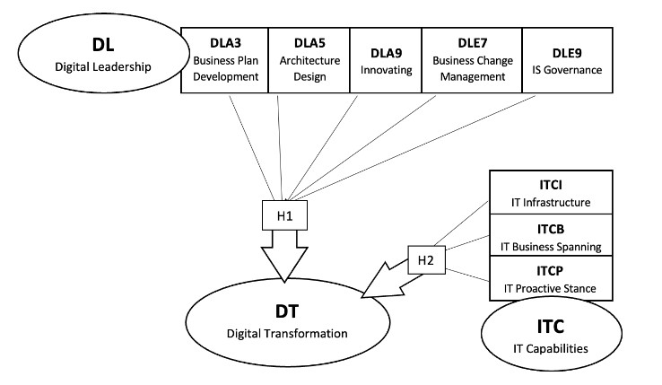

The ITC sub-constructs have been classified into three dimensions, namely IT Infrastructure (ITCI) Capability, IT Business Spanning (ITCB) Capability, and IT Proactive Stance (ITCP) (Nwankpa and Roumani, 2016). This allows to cover capabilities related to IT-related resources, assets, skills, and knowledge. The DL sub-construct is a subset of the needs of the Digital Transformation Leader Role according to the e-CF (CWA 16458-1:2018 (E), 2018, p. 33): Business Plan Development (DLA3), Architecture Design (DLA5), Innovating (DLA9), Business Change Management (DLE7) and IS Governance (DLE9). For this conceptual model the codes from the e-CF framework have been modified by adding “DL” to clearly distinguish between the ITC constructs and the DL constructs.
The squares H1 and H2 represents two hypotheses associated with the subcontracts, that we want to demonstrate with the research conducted in this paper and that will be described in the next Section 4.

RESEARCH METHODOLOGY
In order to understand the impact of individual IT Capabilities and Digital Leadership competences on the Digital Transformation of organisations, the following hypotheses were formulated:

H1: Architecture Design (DLA5), Innovating (DLA9) and Business Change Management (DLE7) have a more positive impact on DT than other DL competences.

H2: IT Business Spanning (ITCB) and IT Proactive Stance (ITCP) have a more positive impact on DT than IT Infrastructure (ITCI).

In the case of the first hypothesis, H1, findings in the literature on the positive effect of vision, innovation and experimentation on DT (Kane et al., 2018; Krug et al., 2018) suggest that the DL competence Innovating (DLA9) may have a significant impact on DT. Similarly, as Business Change Management (DLE7) and Architecture Design (DLA5) provide the strategy and frameworks for the transformation process they may also be crucial for DT.

Regarding the second, H2, IT business spanning (ITCB) was selected because of the importance of IT management which is repeatedly highlighted in the literature (Li & Chan, 2019; Lu & Ramamurthy, 2011). As the ability to create, transfer and retain knowledge (Li & Chan, 2019) as well as to redesign processes, products and services using technology (Nwankpa & Roumani, 2016) is considered crucial for DT, IT Proactive stance (ITCP) may also play a more important role in DT.
The next sections will present a further analysis on the target groups and participants and introduce the methodology used in the analysis of this study.
Target groups and participants
As seen in Figure 3, the research target groups focus on SMEs (51%) but also include Large-Caps and Mid-Caps from industries ranging from Information and Communication to Manufacturing or Financial and insurance activities, as depicted in Figure 2.
Figure 2 - Industry Distribution in % Figure 3 - Firm Size in %
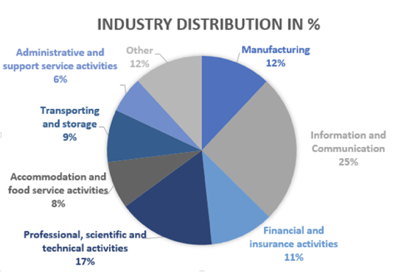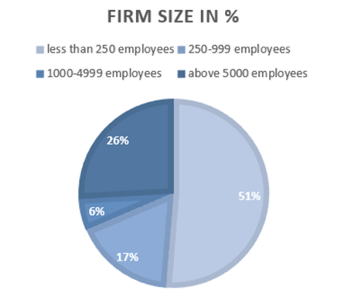

This diversity in targets aims to provide an insight into how DL competences and ITC affect DT in organisations in general but also provides an opportunity to use the data in future research to examine specific sectors or organizations such as SMEs and if or how the effect of DL and ITC on DT differs depending on the type of organisation or industry. To answer the research question in this study quantitative data gathered from 2018 to 2019 through a survey with 433 participants from a variety of different companies and industries in Europe has been used.

Methodology and Variables

The data from the survey was cleaned in SPSS and all answers from the survey that were coded with 0 (I don’t know) were considered missing values to avoid
miscalculations. All Variables that were used in the quantitative data analysis were then set to scale as a 7-point Likert scale was used in the survey. As a next step, the construct variables to be used for the analysis of the influence of ITC and DL on DT were computed. For this, each construct variable was created by calculating the mean of the associated item variables. The overall construct variable was then created by calculating the mean of the associated construct variables. Table 1 shows the relation between construct variables, item variables and the overall construct
variables:

Overall Construct Variables | Construct Variables | Item Variables
ITC | IT Infrastructure (ITCI) | ITCI1; ITCI2; ITCI3; ITCI4
 | IT Business Spanning (ITCB) | ITCB1; ITCB2; ITCB3; ITCB4
 | IT Proactive Stance (ITCP) | ITCP1; ITCP2; ITCP3; ITCP4
DL | Business Plan Development (DLA3) | DLA3.1; DLA3.2; DLA3.3
 | Architecture Design (DLA5) | DLA5.1; DLA5.2; DLA5.3
 | Innovating (DLA9) | DLA9.1; DLA9.2
 | Business Change Management (DLE7) | DLE7.1; DLE7.2; DLE7.3
 | IS Governance (DLE9) | DLE9.1; DLE9.2
DT | DT | DT.1
 |  | DT.2
 |  | DT.3
Table 1: Computed variables

The construct variables IT Infrastructure (ITCI), IT Business Spanning (ITCB) and IT Proactive Stance (ITCP) make up the overall construct variable ITC and the construct variable IT Infrastructure (ITCI) in turn is the mean of the variables ITCI1, ITCI2, ITCI3 and ITCI4. A reliability analysis was then conducted for the item variables from Table 1, to assess whether the variables are internally consistent and can be used for further analysis of the relationship between the different concepts. For this reliability analysis Cronbach’s alpha was used as it is the most widely used objective measure of reliability and is an efficient measure when comparing multiple items (also see paragraph 5.1).
Methodology for Quantitative Data Analysis
To provide a robust analysis of the data collected, a Pearson’s correlation analysis was carried out after ensuring that the requirements for such an analysis had been met. Pearson’s Correlation was chosen as it can be used to measure correlations within and between sets of variables and to show how strong linear relationships between pairs of continuous variables are as well as the direction they are taking (Kent State University Libraries, 2020). The Pearson’s correlation analysis was first
conducted for IT capability (ITC) variables ITCI, ITCP, ITCB and Digital Leadership (DL) variables DLA3, DLA5, DLA9, DLE7, DLE9. After examining
the correlations, it was then decided to create scatter plots for both the highest (DLA5) and lowest (ITCI, DLE9) correlations to identify outliers and further interpret the relationship between the variables. As a next step, to ensure precision around the regression coefficients and to avoid bias in the regression model, assumptions for using regression were tested.
ANALYSIS AND RESULTS
This section presents the results of the analysis conducted using the quantitative data from the survey. It opens with the reliability analysis using Cronbach’s Alpha, then proceeds with Pearson’s correlation analysis and lastly scatter plots to further examine the relationship between the variables.
Reliability Analysis
For the reliability analysis, a Cronbach’s Alpha value has been calculated for each Construct, as shown in Table 2. It is important to remark that a higher Cronbach’s alpha value is linked to a higher covariance of the individual variable (Goforth, 2015). This means that the variables analysed have shared covariance and are thus likely to measure the same underlying concept.

Construct | Cronbach's Alpha
DT | ,920
All individual DL and ITC constructs together | ,955
ITCI | ,894
ITCB | ,940
ITCP | ,936
DLA3 | ,884
DLA5 | ,924
DLA9 | ,889
DLE7 | ,918
DLE9 | ,919

Table 2: Cronbach Alpha
Although all values can be considered significantly high, the variances in the values can be explained by some variables being slightly more independent but not to a significant extent. Table 2 shows that the Cronbach Alpha values for each construct were all above 0.7, and can thus be considered high, indicating that the variables are internally consistent and can be used for the analysis (Tavakol & Dennick, 2011)

The correlation between individual ITC and DL competences and DT

Pearson’s Correlation
To answer the research question “Which DL competences and ITC have a significant influence on DT in organizations?” a Pearson’s correlation analysis was conducted. This analysis examined the correlation between the individual construct variables, i.e. ITCI, ITCB, ITCP, DLA3, DLA5, DLA9, DLE7 and DLE9, and Digital Transformation. The results are shown in Table 3.

 |  | Dependant Variable: DT
 | p-value | Pearson’s r | R² Linear
ITCI | ,000 | ,559** | ,312
ITCB | ,000 | ,620** | ,384
ITCP | ,000 | ,648** | ,420
DLA3 | ,000 | ,659** | ,434
DLA5 | ,000 | ,706** | ,498
DLA9 | ,000 | ,618** | ,382
DLE7 | ,000 | ,629** | ,396
DLE9 | ,000 | ,562** | ,316
** Correlation is significant at the 0.01 level (2-tailed).
Table 3: Values for relationship between DT and individual ITC, DL variables
The r-coefficients of Table 3 show that there is a strong positive correlation (r = 0,706; p<0,001) (Baarda et al., 2014) between the Digital Leadership competence Architecture Design (DLA5) and Digital Transformation (DT). The other ITC and DL variables have been found to have a moderate positive correlation with Digital Transformation (DT) with the lowest value being found for IT Infrastructure (ITCI) (r = 0,559; p<0,001). IS Governance (DLE9) was found to have the second lowest score (r = 0,562; p<0,001). It seems that after Architecture Design (DLA5) (r = 0,706; p<0,001), IT Proactive Stance (ITCP) (r = 0,648; p<0,001) and Business Plan Development (DLA3) (r = 0,659; p<0,001), have the highest impact on Digital Transformation out of all variables.
Furthermore, Table 3 depicts a summary of all R square values and further supports findings from the Pearson’s correlation analysis for the individual ITC and DL variables as Architecture Design (DLA5) has the highest R square value, thus the highest rate for explanation of the variation in Digital Transformation (DT). The R square values for IT Infrastructure (ITCI) and IS Governance (DLE9) are relatively low, suggesting that the relationship between these two variables and Digital Transformation is rather weak. As for the remaining ITC and DL variables the R square values suggest that they explain a smaller share of variation in
Digital Transformation.

SCATTER PLOTS
To further examine possible reasons behind the lower values for IS Governance (DLE9) and IT Infrastructure (ITCI) and to visualize the relationship between each of these variables and Digital Transformation (DT) two scatter plots were created. The R Square value 0,312 for the relationship between IT Infrastructure (ITCI) and Digital Transformation (DT) indicates that the regression model for the scatter plot in figure 4 accounts for only 30% of the variance. Similarly, the R Square value 0,316 for the relationship between IS Governance (DLE9) and Digital Transformation (DT) indicates that the regression model for the scatter plot in Figure 5 also accounts for only 30% of the variance. Although the R Square values are quite similar for both relationships, the correlation between the different variables differs significantly. While Figure 4 shows a rather weak positive correlation between IT Infrastructure (ITCI) and Digital Transformation (DT), Figure 5 shows little correlation between IS Governance (DLE9) and Digital Transformation (DT). Furthermore, Figure 4
indicates that if IT Infrastructure is perceived to be superior, the level of Digital Transformation increases. When IT Infrastructure is perceived to be average however, the level of Digital Transformation varies. This raises the question of whether possessing superior Digital Leadership competences may enable an organization to drive Digital Transformation by providing guidance for how to leverage existing IT Infrastructure. Furthermore, some outliers in Figure 4 could suggest that some respondents may either perceive the different levels of the Likert scale differently or may not possess the required knowledge. For example, an organization with poor IT infrastructure such as poor network communication services and poor application portfolio and services would be presumed to face
difficulties in integrating and shifting to new digital technologies.

Figure 4 - Relationship between DT and ITCI
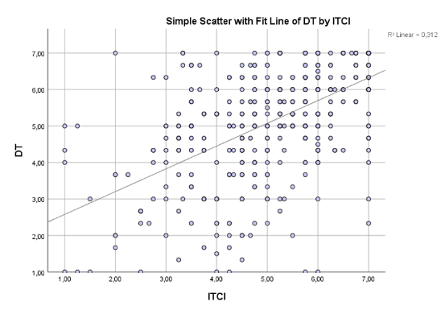
The large variation in responses as well as the large residuals in Figure 5 suggests that either IS Governance (DLE9) does not have a significant impact on Digital Transformation or that participants may not have understood the concept correctly. As there was a high number of missing values for the DLE9 section, the latter may be suspected. Nonetheless, it can be observed, that in cases of superior IS Governance (DLE9) there may be an association with higher levels of Digital Transformation. As the variance in responses is too high however, this competence
may need to be adapted in the survey and examined further.
Figure 5 - Relationship between DT and DLE9
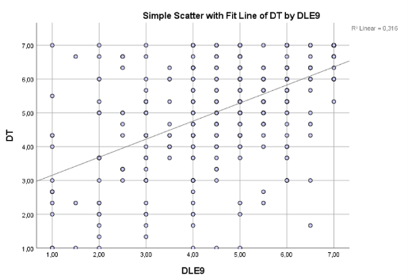

To offer a visual comparison to the scatter plots of both DLE9 and DT as well as ICTI and DT Figure 6, which shows the relationship between Architecture Design (DLA5) and Digital Transformation (DT), was created.
Figure 6 - Relationship between DT and DLA5

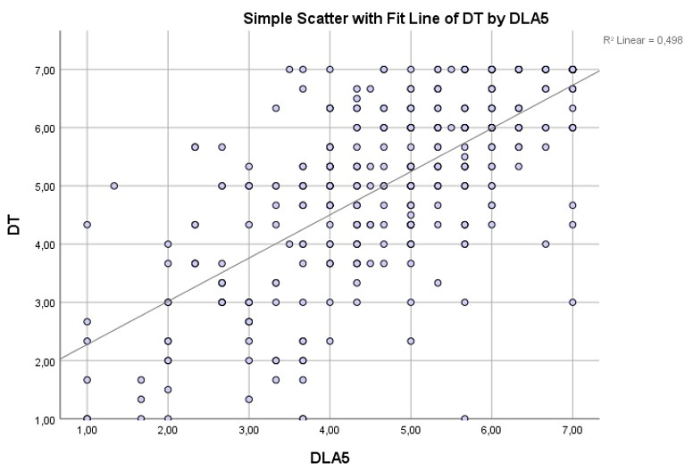
The R Square value 0,498 for the relationship between Architecture Design (DLA5) and Digital Transformation (DT) indicates that the regression model for the scatter plot in Figure 6 accounts for 50%. Moreover, as the residuals in the scatter plot in Figure 6 are much smaller than for ITCI and DLE9 this indicates that DLA5 is more strongly related to DT than ITCI and DLE9.

CONCLUSIONS
The work presented in this paper shows the full methodology applied to find the ITC and DL competences with the highest impact - for both individuals and companies – that enable companies to be competitive at the market using digital technologies.
Some important remarks are with respect to the specific DL competence of Architecture Design (DLA5), as it has the most positive affect on DT overall. Thus, organizations that possess this competence are more likely enabled to adopt digital technologies and digitally transform more successfully. Nonetheless, the results do not entirely support hypothesis 1, as Pearson’s correlation analysis showed that although Architecture Design (DLA5) is the most positively correlated variable with DT, Business Plan Development (DLA3) is more positively correlated with DT than Innovating (DLA9) and Business Change Management (DLE7).
The results from the analysis of the influence of individual IT Capabilities on DT coincide with indicators from the literature that ITCB and ITCP may be more significant for DT than ITCI. As Pearson’s correlation analysis showed IT Business Spanning (ITCB) and IT Proactive Stance (ITCP) to be more positively correlated with Digital Transformation (DT) it can be said that hypothesis 2 is supported. ITCB and ITCP have the most positive effect on DT, therefore these are specifically essential IT Capabilities which organizations wishing to adopt digital technologies should focus on.
Nonetheless, while focusing on building the DL Competences and ITC that have been found to have a higher impact on DT in this study can be of an advantage to organizations, it remains important to consider the findings of previous studies that the overall concepts of ITC and DL have a significant positive impact on DT. DL Competences and ITC that have been found to have a lower impact on DT should therefore not be neglected. While this study has built on fundamental studies on the relationship between ITC, DL and DT (Nwankpa & Roumani 2016; Ravesteijn and Ongena, 2019) it has further confirmed the positive influence of high ITC and DL competences on DT. The additional value that this study brings is that it has found which individual competences and capabilities organizations should primarily focus on to ensure successful DT.
There are some limitations that must be considered. First, the sample used in this study was rather small and included mostly SMEs and organizations with superior ITC. It may therefore be of interest to further research DL competences and ITC in large enterprises and organizations with inferior ITC or to study the relationship between DL, ITC and DT in specific sectors or types of organisations such as SMEs. The rather large number of missing values for DLE9 also suggest that the definition of this competence that was used in the survey must be altered to provide a clearer understanding of the concept. This study not only provides companies with a valuable insight to the competences they may take into consideration in their recruitment if they aim to succeed in DT, it also provides an opportunity to study Architecture Design (DLA5) in more detail to examine which aspects of this digital competence provide the most value to an organization. Lastly, another opportunity that has emerged from this study is to examine how these findings are related to adopting specific technologies such as Artificial Intelligence.

Acknowledgements
This publication has been partially supported by the Science Foundation Ireland under Grant number 12/RC/2289-P2 which is co-funded under the European Regional Development Fund

REFERENCES

Boomer, L. G. (2019). 10 skills for digital leadership. Accounting Today, 33(1), 24-24

Chakravarty, A., Grewal, R., & Sambamurthy, V. (2013). Information technology competencies, organizational agility, and firm performance: Enabling and facilitating roles. Information Systems Research, 24(4), 976-997.

Chou, S. (2019). the fourth industrial revolution: Digital fusion with internet of things. Journal of International Affairs (New York), 72(1), 107-120.

CWA 16458-1:2018 (E). (2018, August). European ICT professionals role profiles - Part 1: 30 ICT profiles. European Committee for Standardization.

Davenport, T. H., & Westerman, G. (2018). Why so many high-profile digital transformations fail. Harvard Business Review, 9, 15.

Goforth, C. (2015, November 16) Using and Interpreting Cronbach’s Alpha. University of Virginia Library. https://data.library.virginia.edu/using-and-interpreting-cronbachsalpha/

Hüsing, T., Korte, W. B., Fonstad, N., Lanvin, B., Cattaneo, G., Kolding, M., ... & van Welsum, D. (2013). E-leadership: E-skills for Competitiveness and Innovation–Vision, Roadmap and Foresight Scenarios. prepared for European Commission.

Kane, G. C., Palmer, D., Phillips, A. N., Kiron, D., & Buckley, N. (2018). Coming of age digitally: Learning, leadership, and legacy. MIT Sloan Management Review and Deloitte Insights.

Kent State University Libraries. (2020), November 10). SPSS tutorials: Pearson Correlation. https://libguides.library.kent.edu/SPSS/PearsonCorr

Krug, P., Weiß, M., & Lang, J. (2018). Digital leadership: Führung im zuge der digitalen transformation. Wirtschaftsinformatik & Management, 10(6), 48-59.

Li, T., & Chan, Y. E. (2019). Dynamic information technology capability: Concept definition and framework development. The Journal of Strategic Information Systems, 101575.

Lu, & Ramamurthy, K. (. (2011). Understanding the link between information technology capability and organizational agility: An empirical examination. MIS Quarterly, 35(4), 931-954.

Mikalef, P., Boura, M., Lekakos, G., & Krogstie, J. (2019). Big data analytics capabilities and innovation: the mediating role of dynamic capabilities and moderating effect of the environment. British Journal of Management, 30(2), 272-298.

Moreira, F., Ferreira, M. J., & Seruca, I. (2018). Enterprise 4.0 – the emerging digital transformed enterprise? Procedia Computer Science, 138, 525-532.

Nwankpa, J. K., & Roumani, Y. (2016). IT capability and digital transformation: A firm performance perspective.

Prentice, W.C.H. (1961). Understanding leadership. Harvard Business Review, 39(5), 143– 151.

Ravesteijn, P., & Ongena, G. (2019). The role of e-leadership in relation to IT capabilities and digital transformation. Proceedings of the 12th IADIS International Conference Information Systems 2019, IS 2019, 171–179.

Saldanha, T. (2019). Why digital transformations fail: The surprising disciplines of how to take off and stay ahead (First ed.). Oakland, CA: Berrett-Koehler Publishers, a BK Business Book.

Tavakol, M., & Dennick, R. (2011). Making sense of Cronbach's alpha. International journal of medical education, 2, 53.

Venkatraman, V. (2017). Digital matrix: New rules for business transformation through technology. United States: Lifetree Media Ltd.

