Analyzing Social Media Implementation in Hospitals in the U.S. Midwest Region

Dalsang Chung¹
C. Christopher Lee²

¹Governors State University
²Central Connecticut State University

ABSTRACT

The purpose of this research is to explore to what scale hospitals are adopting social media and implementing it with respect to the hospital characteristics. We conducted a review of the hospitals’ social media activity on social networking sites like Facebook, Twitter, Instagram, and YouTube. We studied all the 912 hospitals in the Midwest region reported in the 2015 American Hospital Association annual survey data. We reviewed the social networking websites of these hospitals to understand the scale of social media adoption relative to the hospital characteristics such as bed count, state, ownership type(control), specialty(service), whether the hospital is in a network, and whether the hospital is a physician-owned or not. We determined the utilization with the data from user activity on each different social networking platform such as likes on Facebook, followers on Twitter and Instagram, and subscribers on YouTube. More than 80% of the hospitals have their presence on at least one social networking website but the utilization depends on many factors of the hospitals' characteristics. We observed that hospitals in Ohio, government-owned, children’s specialty hospitals with more full-time registered nurses have higher social media utilization.

Keywords: Social Media, Hospitals, Hospital characteristics, 2015 AHA Data

INTRODUCTION

Almost 79 percent of the people in United States use internet are active on social network website Facebook (Greenwood, et al., 2016). With the number of people on social networking, most of the entertainment, food, electronics, automobile, beverage businesses across the industries have made their presence on social networking platforms to reach their potential customers and keep in touch with them all the time. This is an effective way of marketing and building strong relationship with the customers. This social networking strategies might be followed by hospitals too, to reach out to the patients and to constantly be in touch with the people giving out healthcare information and news. But we know very less about the usage of social media platforms by the hospitals (Glaser, 2016). Adopting the plan of action to be active on social media platforms would increase the hospital’s market share and popularity and gives an opportunity to develop their missions on healthcare agendas. Hospitals cannot have a complete control over the discussions and comments on social media, but they could drive the social media with their presence and strong content. Online health groups and communities created by the hospital, patients and people who involve in the groups, employees of the hospital, etc. are the people who would be responsible for the content of healthcare and hospital related information. This whole process wouldn’t actually cost anything for the hospitals. Social media websites play a very important role for clinics and hospitals in reaching out directly to patients, consumers and their families, also helps in broadcasting information related to wellness and health, appreciate staff, promote health services and products and taking feedbacks and opinions from the patients about those services. (Kordzadeh N, 2015).

Audience Engagement

Relationship between hospitals and patients starts when a patient logged into the hospital records and ends when he is done with his/her treatment. But nowadays, the relationship is continuing as he check-in to the hospital on its social media web site (Christina, 2011). when a hospital creates a Facebook page and posts healthcare information and latest news about the hospital facilities and stuff, it’s marketing in a way, giving information to the people they connected on Facebook which empowers the patients and their families who look for the information regarding the hospital and healthcare information (Raina, 2014). The likes on Facebook could not totally be accurate with respective to the actual popularity of the hospital but it gives an edge to analyze the data with some statistics and surveys. And lot of factors may give different understanding such as most of the likes for a hospital comes from a set of people who live in the neighborhood.
Information dissemination, the ratings on Facebook, Instagram and other social media platforms reflect the service, performance and patient experience of the hospital. Hospitals are using YouTube videos to educate the patients to introduce the procedure, pre-operative preparation, post-operation follow ups and such information which could be informative for the patients and people who go through process and also can reduce the fears and encourage them to engage in taking their own care (Huang, E, 2013). Maintaining the social media relationships among hospital, patients, healthcare processes and researches are being evolved fast day by day. It has become highly important that hospitals are discovering innovative ways to keep in touch and engage with the patients who are outside the hospital environment.

Social Media Utilization by Hospitals

In the modern technology age, people are more active and easily approachable through social media platforms than mails and phone communications and since it’s cost effective and easy for the hospitals to adopt and implement the strategies to embrace social media presence (Larsson, et al., 2016). With Physicians using social media it brings down many barriers between patients and physicians as they can directly get the guidance and by this and we can directly get an insight into how these modern technology tools are helping physicians, Physicians being on social media also helped them in research field, advancing their career and learning new things by interacting with many medical professionals. One of the main benefits of physicians on social media are that they can easily have access to more descriptive, precise and more reliable information (Lauren, 2016). Even though the social media has raised some hospitals are unconvinced and reluctant to use social media. The Ohio Hospital Association pretends that even though the social media usage has increased, only 15% of their hospitals dedicate full-time professionals to maintain their social media sites (Newswire, 2013). Furthermore, some health care professionals in rural and suburbs have reservations to use social media as privacy and security concerns. They even think that social media can cause negative publicity of hospital through negative comments from patients (Richter, 2014). On the flip side, hospitals are succeeding in implementing social media with minimal expenditure. The targeted audience through a Facebook post, Twitter tweets, YouTube videos, and Instagram uploads are immense. In this study, we attempt to explain the adoption & utilization of social media among hospitals in Midwest region and analyze whether the adoption & utilization of social media changes from hospital to hospital depending on its characteristics like profit status, bed count and so on.

LITERATURE REVIEW SOCIAL MEDIA

Social networking started with people’s desire to be connected with their old school friends. This later evolved into social media sites that enable people to get connected and share thoughts with others in the same community (Facinelli, 2009) (Hackworth, 2010). Health care, industry suppliers, trade organizations, area developers, franchises, and potential franchises, and consumers are already into social media based communication. This form of communication is accessible, flexible and easy to use. Social media makes a greater part in business growth. Every brand needs to have a social media presence (Hackworth, 2010). The way businesses are communicating with their customers have changed a lot with web applications, which simultaneously connects business with vast audience. The other major advantage of social media communication is it allows businesses to communicate with its customers in their personal space (at homes, after hours) (Facinelli, 2009). Businesses can use social media in two ways, building a new application or using the existing ones. They can build a new application which generates viral campaigns. But this would be difficult as they need to spend some resources like time and human efforts to do this. The later one is easy to use the existing application, which is effortless, and no expertise is needed for this. They can use existing brand sites that are being used by billions of users across the country, which makes them easy by eliminating search for audience.

Social Media in Health Care

Healthcare industry has struggled a lot to understand the impact of social media on their respective healthcare services from an organizational point of view but it’s clear that usage of social networking sites to share health related information would grow exponentially. There is a demand from patients and consumers that they need to have access to timely healthcare data from medical experts, which lead many hospitals to adopt and embrace the social media platforms to connect with the patients and consumers. (Michael, C. A. 2013). The process of progress occurring require revamping and upgrading healthcare associations who now wind up deciding whether to change their traditional frameworks, described by strict and inflexible arrangements of data, to ending up as new associations that can recombine the global needs considering local demands (Ginevra, 2013).
In this situation, hospital need to create viable communication forms, encouraging clinic-patient relationship, actualizing and sharing data, reacting to patient’s feelings, overseeing vulnerability, empowering to make decisions and encouraging patient’s self-managements.

Social Media Adoption Across US

Social networking sites provides various features that enables users to fulfil their individual needs. Generally, people use social networks like Facebook, twitter to share their status, pictures and get engaged with people whom they are connected to. Other than this they use these platforms to get connected and frequently updated with the information they desire. YouTube is used to watch and share videos. Social media population has been increased over the few years drastically all over the world, especially in the states where the usage of social networking sites has increased from 8% to 72% in 9-year period from 2005 to 2013 (George, et al., 2013). People of all ages and professions are using social networking sites frequently. As of now 2017, people who are using Facebook have exceeded 2 billion worldwide and Twitter users number has crossed 284 million, and 3.25 billion videos are viewed on YouTube. Social media is an electronic tool that enables communication, collaborate relationship and allows users to share context globally. These social networking sites enable hospitals to maintain personal connects with the patients in a community and people who they serve. Social media depth is still undiscovered, and its usage is still in infancy. No matter what ever the organization it would be social media gives an identity to the organization beyond name and standard of care (Sarringhaus, 2011). More over social media adoption and utilization in hospitals is budget neutral. With the most available social media options like Facebook, Twitter, YouTube and so on, they are freely available on cloud. Only cost associated with are marketing professional and human resource department who manages it.

Facebook

This is the most eminent social networking site that allows people around the globe to communicate with each other, in an easy yet effective way (Hackworth, 2010). As of now 2017, people who are using Facebook have exceeded 2 billion worldwide. Hospitals use social media to get in touch with people who live in the same community. They post something related to health and awareness that reaches people who opens it and read it and then like or dislike it. Whenever a person visits a hospital facility they check-in saying what are their feelings being at that place. People can search for hospitals home page and as they like the page, they start receiving news feeds and posts that they can like or share.

Twitter

It is a microblogging social media platform that enables users to post 280-character messages so called tweets. This distinctive social media is growing day by day and its now to crossed 284 million users. With the rapid usage of internet, it has impacted on how users interact, share their experiences and make a living, among many other ways of connecting microblogging is very much current way of directly approaching desired person of contact, Twitter is a best example for that, there are situations in which social media channels like Twitter come very handy and play a very crucial role in getting the right data and the most effected persons in times of crisis, for this we can take an instance when H1N1 Pandemic occurred where key words were used to get more information regarding sharing resources, statements of personal experiences, opinion,humor, frustration, concern, misinformation and questioning which gives all the required data for the organizations working on it for a better way of service and can make much more efforts.

Instagram

Like Facebook and twitter, Instagram too enables users to hold a profile through which they can upload photos into their cloud space. They do get news feed through which they can share their feeling for the uploaded photo. It has been estimated that there are 500 million users around the globe who use Instagram to share photos and news feeds. Yet hospitals, they just began to use Instagram as a tool to attract people. They can use Instagram to be identifiable by posting content about good health practices, and advertise for wellness events whenever necessary.
The Key for hospitals to get connected with people is to be consistent with their posting content (Smith, 2016). They can get into communities empowering people about their brand through their posts

YouTube

It is the most popular video hub, that allows users to post their media content on web that can be viewed by people from any part of the world. The major advantage of YouTube is that its free, flexible, and easy to use. Hospitals can use YouTube to upload media related to their policies and services available at their facilities. As an instance, hospital can post videos of their admission process, through which they can reduce complications in their admission process. They can post videos of critical cases that they have solved any suggest some preventive actions to people to be away from those kinds of diseases (Hackworth, 2010).
The only thing people need to do is to subscribe to YouTube channel related to hospital, to get notifications about videos that are being posted by hospital.
These videos provide valuable information to the users, and good advertisement to the hospital brand too.

METHODOLOGY DESIGN OF THE STUDY

We have collected the hospital-related social media activity on four popular social media platforms Facebook, Twitter, YouTube, and Instagram. For each of the platform, we have reviewed the adoption and utilization of social media among the hospitals in Midwest region. To understand the adoption of social media by the hospital, we will analyze the hospital’s existence and number of accounts following the hospital as the parameter. And in order to understand the utilization of social media by the hospital, we will analyze the hospital’s activity and frequency of posts as the parameter.

Population of the Study

We included hospitals in Midwest region reporting complete data to the 2016 American Hospital Association Survey (AHAS). The study included 912 hospitals in the region. Hospital characteristics were derived from the AHAS, including Control status (public, private nonprofit, private for-profit), bed count (small: less than 99 beds; medium: 100 to 299 beds; large: 300 or more beds), and state (Illinois, Indiana, Ohio, Michigan, Wisconsin), service(the hospital’s specialty), Network(Whether the hospital is participating in a Network), Physician Owned(Is the hospital a physician owned or not), Total Outpatient Visits, Total Capital Expenditure, Doctors(Full-time physicians & dentists), Full-time Registered Nurses, Full-time medical & dental residents and interns and Full-time licensed practical or vocational nurses. We extracted data for each hospital from the 4 social media platforms. Data included whether each hospital had an account (adoption) and, if so, activity on each social media account (utilization). These platforms were selected because of their widespread popularity, free public access, and availability of posted usage metrics. Webpages on Facebook, Twitter, Instagram and YouTube are created by hospitals. Hospitals can create accounts and then post messages and pictures through these accounts to their followers.

Data Collection

To acquire information from every one of the four social networking platforms, we initially identified the website for every hospital through an Internet web search utilizing the hospital names from the AHAS study. We made a note of the links to the respective social media webpages of the hospital which are on the hospital’s website connect us space. If at all the hospital doesn’t have any information regarding its social media platforms on its website, we performed a direct search for the hospital’s account on all the four platforms. In these cases, the character of every hospital’s online networking website page was verified by checking the address of the hospital on the social networking page with the known address of the hospitals from AHAS surveys. We determined the adoption of social media by an aspect whether the hospital had a social media account. We determined the usage of social media by the hospital to be a measurement of social media utilization by the hospital which could be recorded from every social networking website. These included number of likes (Facebook), number of followers (Twitter), number of followers (Instagram), and number of subscribers (YouTube). For hospital centers with numerous accounts or pages on 1 platform, we chose either the page created by the hospital. To achieve that as accurate as we could get, we have chosen to not include the information of social media accounts which are not authorized by the hospital. The social media activity has been recorded for a period of one month (October 2017).

RESULTS

We have recorded the percentage of hospitals having Facebook, Twitter, YouTube, and Instagram to determine the adoption of social media platforms across the hospitals in Midwest region. Due to the right-skewed distribution of utilization (likes, followers, subscribers, and insta followers), we report medians and Inter Quartile Range. For the hospital characteristics like state, control, service, network, physician, and bed count ANOVA has been used to find if there is any difference in categories in using each social media. For an instance, as there are 5 states in total we used ANOVA to find if there is any difference in social media utilization between those states. We also used regression procedure to assess the independent associations of hospital characteristics on the magnitude of social media activity. We considered social media utilization as dependent variable and hospital characteristics like total out patients visit, total capital expenditures, full-time physicians, full-time medical interns, full-time registered nurses, and licensed practical nurses as independent variables, and recorded the ones that are significantly able to determine the magnitude of social media utilization. Due to the skewed nature of utilization, we used the log transformation of social media utilization to approximate the normal distribution.
For all analyses, a P value <.05 was considered statistically significant.

Adoption of Social Media is Widespread

Social media adoption by the hospitals varied across different social media platforms, 763 (83.66%) hospitals having Facebook pages, 438(48.02%) hospitals having Twitter handles, 557(61.07%) hospitals have YouTube channels, and 183 (20.06%) hospitals have Instagram accounts. Overall, 289 (31.68%) hospitals had accounts on 3 platforms and 104 hospitals out of 912 has accounts on all the four social media platforms.

Descriptive Analysis of Social Media Adoption

Below pie-charts gives a pictorial understanding of the social adoption with respective to the States in Midwest region, Control of hospitals, Service specialty, bed-count, registered nurses, licensed nurses, full-time physicians. The first chart explains us the number of hospitals in each state. Our research is on hospitals in Midwest region, which includes Ohio, Indiana, Illinois, Michigan, and Wisconsin. From the pie chart we can observe that the number of hospitals in each state are almost equal except in Ohio and Wisconsin, where the number is comparatively high. The pie-chart with control characteristic of hospital tells us that most of the hospitals are Nongovernment and nonprofit (67%). 46% (307) of the hospitals are of small bed count(less than 100 beds), 24%(162) large bed-count(More than 299 beds) hospitals and rest 30%(196) hospitals are of medium bed-count(100-299 beds). 34% (3352) of the vocational-practical nurses are from Ohio. Full-time registered nurses are more in Ohio too with 31%(63,200) followed by Illinois 26% (52,285). And Full-time physicians and dentists are also high in Ohio with 37%(9294) with comparison to other states.

The Hospitals by Service pie-chart gives us the information regarding the specialty of the hospitals. For an instance, Cancer represents the Cancer Specialty Hospital. There are various specialty hospitals such as Heart hospitals, Children psychiatric hospitals, Rehabilitation hospitals, Orthopedic Hospitals and so on. General Medical & Surgical hospitals are very high comparatively to other service hospitals with whopping 700 in number. Followed by Psychiatric Hospitals with 77 and Acute long-term care hospitals with 70. There are 22 Rehabilitation hospitals and the rest of the hospitals are in 1,2,3 or less than 9 in numbers. The total capital expenditure for hospitals is high in the state Michigan with 3,949,357,392 USD and Indiana has the least capital expenditure for hospitals which is 892,577,082 USD. The Total Outpatient visits are more for the hospitals in Ohio with number 43,536,542 followed by Illinois with 41,748,328, Michigan with 38,324,795 number of outpatient visit. Wisconsin state has the least outpatient visits of all the states with 20,173,862.

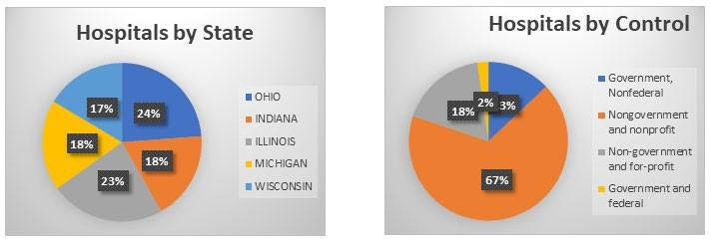

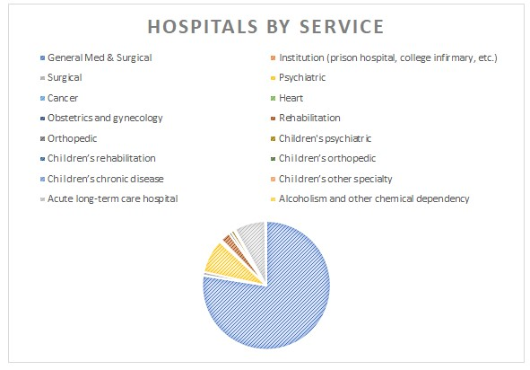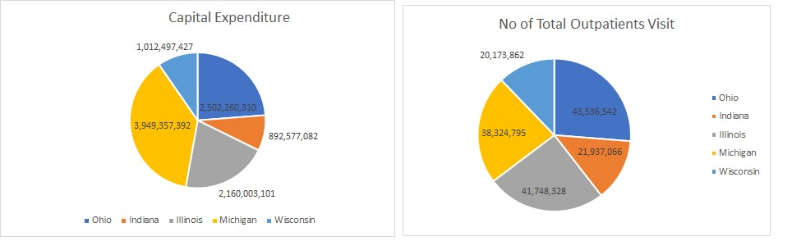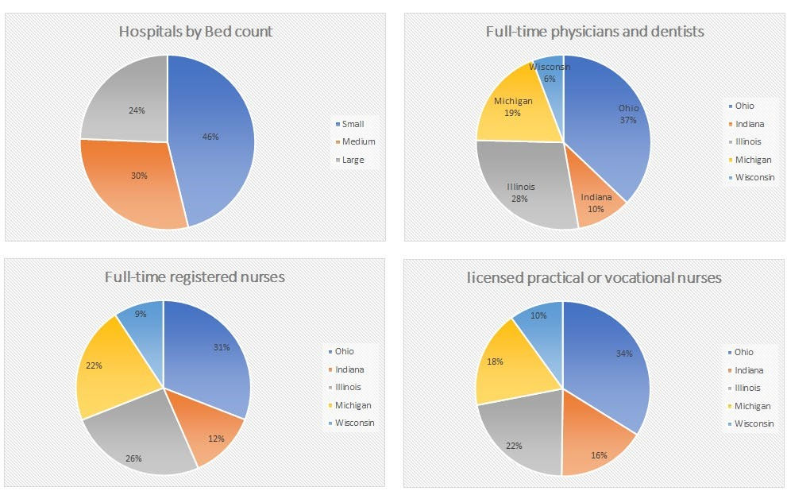

Distribution of Utilization of Social Media across Midwest Region Hospitals.

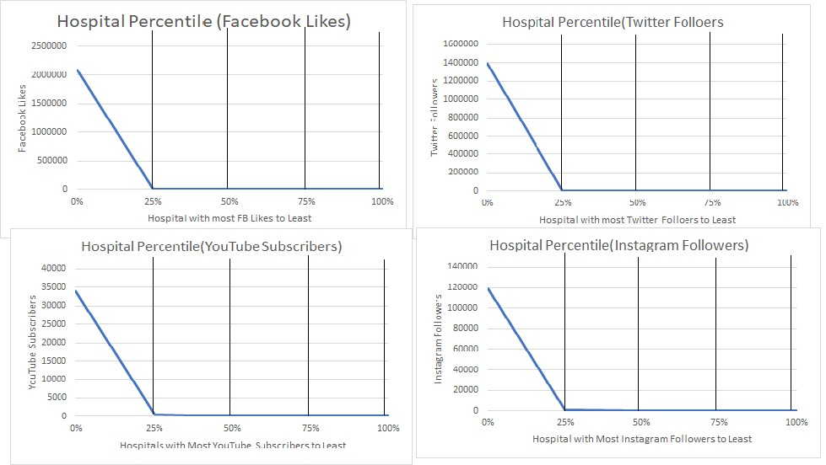

Utilization

Understanding the hospital characteristics with respect to the utilization of social media, Tables 1 and 2 display the magnitude of social media utilization differentiated by hospital characteristics. Hospitals in Ohio state, with larger bed count, under Government/Federal control, which participates in Network and hospitals like Children’s rehabilitation, other specialty had significantly more social media utilization than their comparison groups across all 4 social media platforms. For example, large hospitals (>300 beds) compared to the smallest hospitals (<99 beds) had a median 6901 (IQR 2751-17004) versus median 1311 (IQR 640-2991.5) Facebook likes, median 2567 (IQR 840-7050) versus median 613 (IQR 150-4617) Twitter followers, median 267 (IQR 72-1384) versus median 69 (IQR 7-382) YouTube subscribers, and median 431 (IQR 17-1053) versus median 87.5 (IQR 39-622) followers on Instagram. The utilization of different platforms varies among the states. For example, Facebook and Instagram usage is really high by the hospitals in Ohio region whereas more number of hospitals in Wisconsin are using YouTube than other states. Hospitals in Illinois state are ahead of all other state hospitals in using Twitter platform. Hospitals participating in Network compared to hospitals not participating in Network had a median 3154(IQR 1181-11832) versus 1766.5(IQR 763-4641) Facebook likes, median 2496(IQR 578-6476) versus median 829(IQR 203-3903) Twitter followers, median 80(IQR 10-495) versus median 234(IQR 39-841) YouTube subscribers, median 175(IQR 62-660) versus median 457(IQR 102-934) Instagram followers.
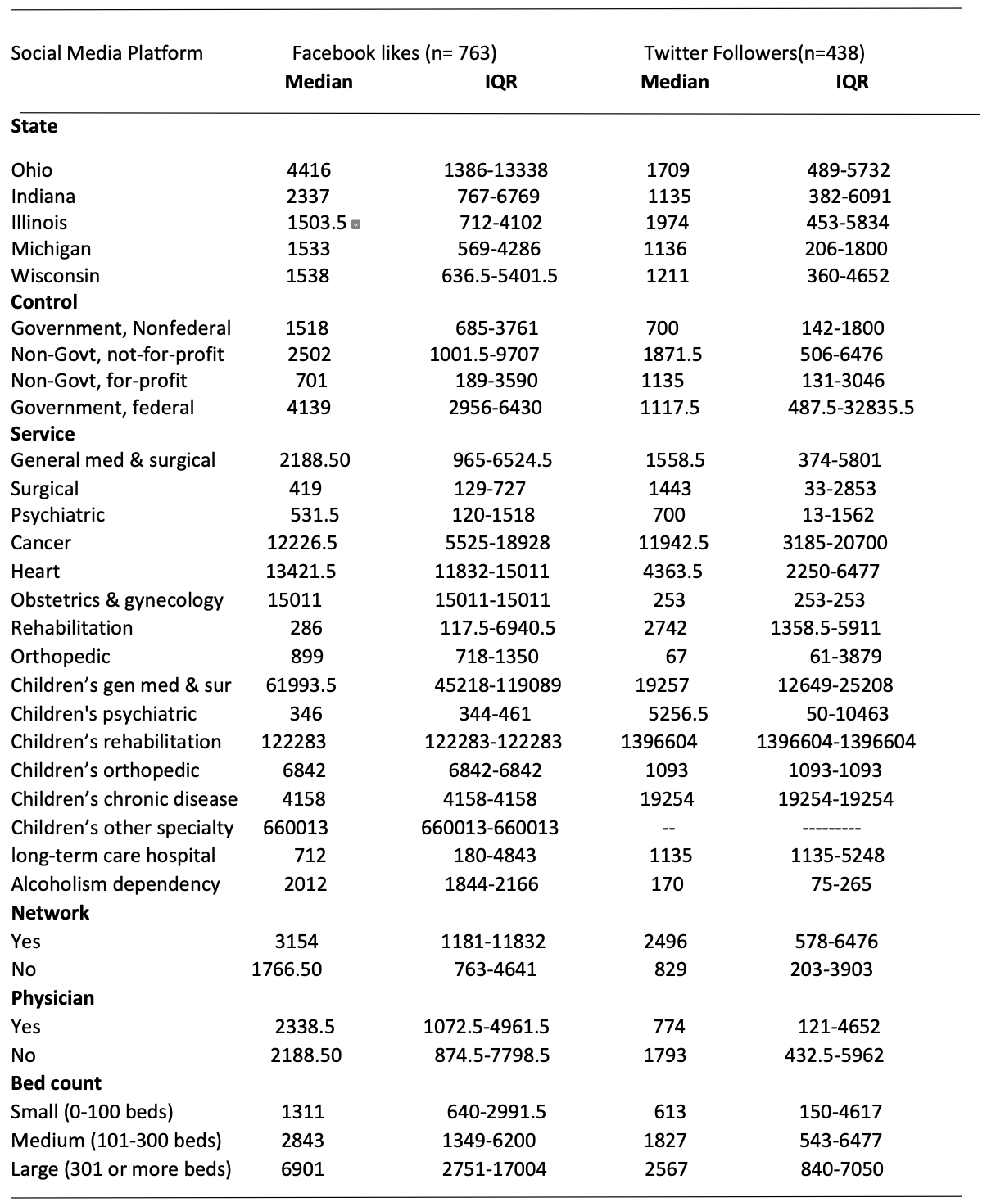
Table 1: Magnitude of social media utilization, Facebook and Twitter

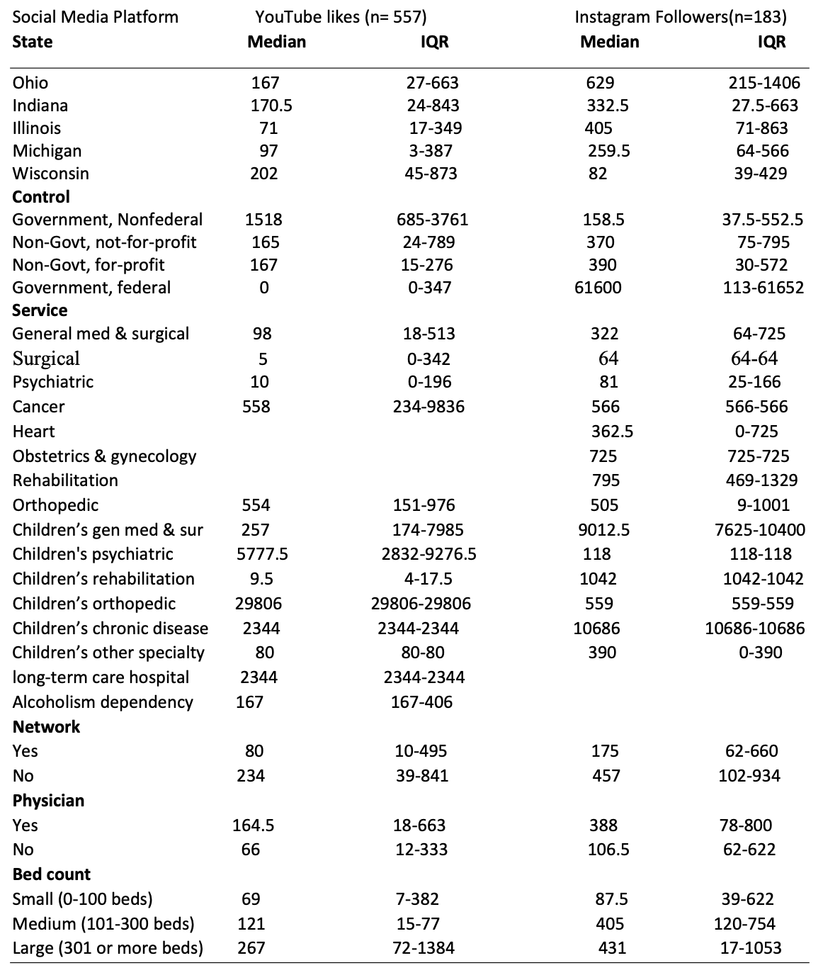
Table 2: Magnitude of social media utilization, YouTube and Instagram

From Table 3 and 4, we could determine the significant characteristics in ANOVA Test results for Facebook, Twitter, YouTube and Instagram. We can see the hospital characteristics that are significant in determining utilization of social media in hospitals. The F-value generally determines the variation between sample means. Here every character has few sub-divisions, for example as there are five states, so F-value 6.76 determines that there is at least one state with different utilization trends compared to others. We have even used ANOVA procedures to determine if there is any difference between states and found out that state OHIO is significantly different from other states. This says that hospitals in Ohio have different trends of social media utilization compared to other states. Hospitals are categorized into four controls Government nonfederal, Non-government and nonprofit, Non-government and for-profit, and Government federal. The F-value for Control 21.44 determines that the hospitals under at least one of these control exhibit significant difference of Facebook utilization compared to other controls. The LSD test for controls say that there is significant difference between all controls except between Government federal and Government nonfederal. The LSD test for the Network characteristic tells us that Facebook utilization is determinant on, if the hospital participates in a network. The Service has many sub characteristics with hospital’s specialty and there are at least 11 significant characteristics. General medical and surgical, Surgical, Psychiatric, Cancer, Heart, Rehabilitation, Children’s general medical and surgical, Children’s rehabilitation, Children's psychiatric, Children’s other specialty, and Acute long-term care hospital hospitals are significant among the 27 specialty hospitals with which we can determine that the utilization of Facebook is significantly high in these specialty hospitals. The Physician owned Hospital characteristic isn’t significant with the utilization as the F-value is 0.07, this shows that neither the hospital owned by a physician nor an outsider there is no significant difference in Facebook utilization. The Bed-count characteristic with Large bed-count is significant comparatively to small and medium bed counts. Hospitals with Larger bed count have high social media utilization.

Whereas in Twitter, we can see that in all the characteristics at least one sub-division has significant difference in Twitter utilization compared to others. The F-value 3.10 for state say that there is at least one state which has different trends in Twitter utilization. From LSD we can see that Michigan has significantly different trends of Twitter utilization compared to other four states. In control from LSD we can see that there is no significant difference between Twitter utilization of hospitals under Government federal - non-government non-profit, and government non-federal-nongovernment for profit. The LSD for service shows that hospitals that provide Children’s rehabilitation service have significantly different Twitter utilization from other services. The LSD test for the Network characteristic tells us that Twitter utilization is determinant on, if the hospital participates in a network. The Physician owned Hospital characteristic is significant with the utilization as the F-value is 4.61, this shows that there is significant difference in Twitter utilization by hospitals owned by physicians and that are not owned by physicians. In Bed count we can see that hospitals with small i.e. (0-100beds) have comparatively different utilization trends to medium and high range hospitals.
Whereas in YouTube, from the ANOVA test results we can see that except State and Physician all other characteristics exhibit significant difference in YouTube utilization. From LSD Test we can see hospitals under Government, Nonfederal Control exhibit significantly different Utilization trends compared to others. Hospitals that provide Children’s rehabilitation, and Children's psychiatric services exhibit different utilization trends compared to hospitals that provide other services.
The LSD test for the Network characteristic tells us that YouTube utilization is determinant on, if the hospital participates in a network. The F-value 12.66 for Bed count and from LSD Test we can see that hospitals from there characteristics small, medium, and large have significantly different YouTube utilization from others.
Whereas coming to Instagram, from ANOVA test table we can see that only state and control have significant difference in Instagram utilization than other characteristic. From LSD test for State, we can see that Ohio state has different trend of Instagram utilization compared to other states. In LSD for Control we can see that hospitals controlled by Government, federal have different trends of Instagram utilization compared to hospitals under other controls.

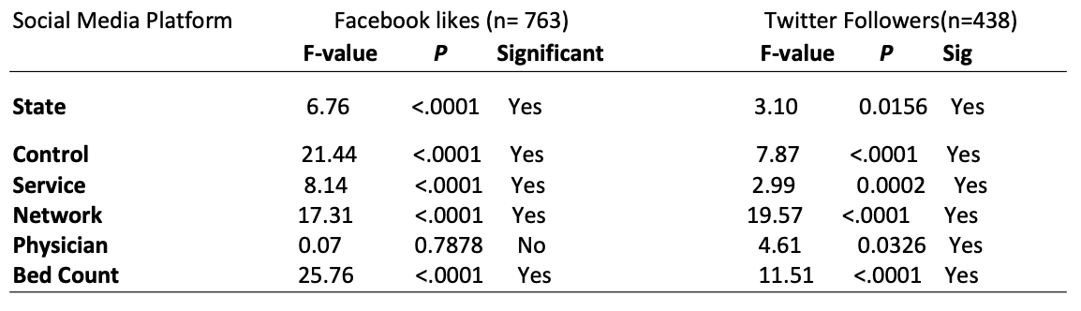
Table 3: ANOVA Test results of social media utilization, Facebook and Twitter

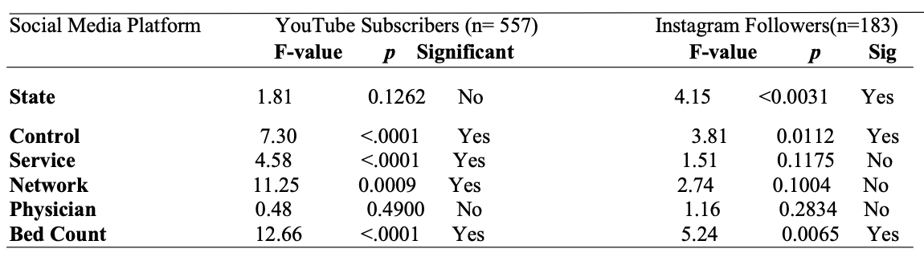
Table 4: ANOVA Test results of social media utilization, YouTube and Instagram

Table 5 and 6 gives us the information on the characteristics which determine the significance of utilization of social media. From the Tables which represents the OLS regression of social media utilization with other hospital characteristics (Total Outpatients visits, Total capital expenditures, Full-time physicians, Full-time medical interns, Full-time registered nurses and Licensed practical nurses) with respect to the four social media platforms Facebook, Twitter, YouTube and Instagram. The Full-time medical intern’s characteristic is significant with Facebook likes and not significant with rest of the 3 social media platforms. It means that more number of Fulltime medical interns in hospitals are reason for high Facebook likes. Full-Time registered nurses are significant for all four social media platforms across all the hospitals in Midwest region. It means that more number of Full-time registered nurses in hospitals are reason for more Facebook Likes, Twitter followers, Instagram followers and YouTube subscribers. (The term ‘Significant’ is the probability that a relationship between variables is caused by something other than random chance. This test provides a p-value, representing the probability that random chance could explain the result; in general, a p-value of 5% or lower is statistically significant.)

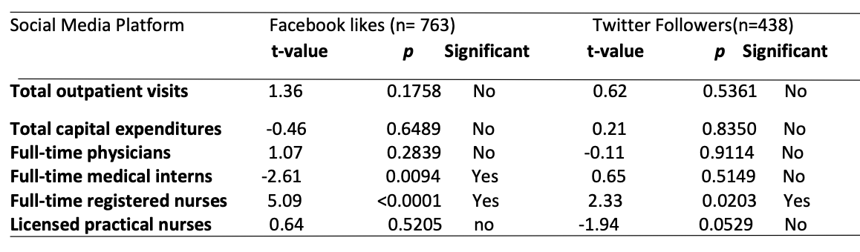

Table 5: OLS Regression of social media utilization, other hospital characteristics
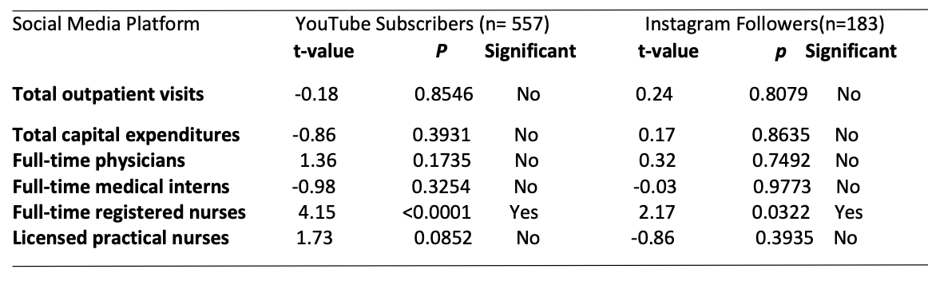

Table 6: OLS Regression of social media utilization, other hospital characteristics

DISCUSSION

For this study, we have researched social media adoption by hospitals in Midwest region. We have collected the number of hospitals which has accounts on four social media platforms Facebook, Twitter, YouTube and Instagram. And, the information, number of likes in the hospital’s Facebook page, number of followers for the hospital’s Twitter handle, number of subscribers for the hospital’s YouTube channel and number of followers for the hospital’s Instagram account. These two sets of data allow us to analyze the adoption and utilization of social media by the hospitals. We define adoption by checking whether the hospital has an account on any of the social media platforms. The adoption of social media varied across platforms, with 763 (83.66%) having a Facebook, 438(48.02%) having a Twitter, 557 (61.07%) having a YouTube, and 183 (20.06%) having an Instagram account. Overall, 289 (31.68%) hospitals had accounts on 3 platforms. 104(11.4%) hospitals out of 912 has accounts on all the four social media platforms. The number of hospitals in Ohio, Indiana, Illinois, Michigan and Wisconsin are 217, 164, 213, 168 and 150 respectively.

We define utilization as how actively hospitals are using each social media account to connect with the people with respect to the 12 hospital characteristics. We collected one-month social media activity from each platform. We performed statistical analysis like ANOVA test and OLS regression analysis to find out which of the hospital characteristics are significantly impacting social media utilization.

From the Univariant procedure results, we can see that Ohio state has higher social media utilization with Facebook likes (Median 4416 & IQR 1386-13338), Twitter Followers (Median 1709 & IQR 489-5732), YouTube subscribers (Median 167 & IQR 27-663) and Instagram Followers (Median 629 & IQR 215-1406) comparatively. The Government, Federal hospitals have more utilization with Facebook likes (Median 4139 & IQR 2956-6430) and Instagram Followers (Median 61600 & IQR 113-61652). Government, nonfederal hospitals have high utilization in YouTube (Median 1518 & IQR 685-3761). Non-Govt, Not-for-profit hospitals have more Twitter utilization with (Median 1871.5 & IQR 506-6476). Children specialty hospitals have higher social media utilization than other specialty hospitals. Children’s other specialty and Children’s Gen Med & Sur hospitals have higher Facebook utilization on Facebook with (Median 660013 & IQR 660013-660013) and (Median 61993.5 & IQR 45218-119089) respectively. Children’s rehabilitation hospitals have higher Median in Twitter with 1396604 & IQR 1396604-1396604. Children’s Orthopedic hospitals have more YouTube utilization with Median 29806 & IQR 29806-29806.
Children’ Chronic disease hospitals used Instagram more than other social media platforms with Median 10686 & IQR 10686-10686. The hospitals which are participated in a Network have more utilization in Facebook and Twitter with Median 3154 and 2496 respectively. Hospitals which do not participate in a Network have high social media utilization in YouTube and Instagram with Median 234 and 457 respectively. The Physician owned hospitals have higher social median utilization on Facebook, YouTube and Instagram with Medians 2338.5, 164.5 and 388 respectively from which we could understand that Physician owned hospitals take social media more seriously than hospitals which aren’t Physician owned. The hospitals which are not Physician owned have higher utilization on Twitter with Median 1793. Hospitals with Large Bed-count have higher utilization on all social media platforms which tells us that huge hospitals are more active on social media than small and medium size hospitals.

The ANOVA test results help us to analyze how sub-characteristics are significantly impacting social media utilization. From LSD test, we can visualize if there’s any significant difference among sub-characteristics impacting social media. After analyzing ANOVA test and LSD test results, we found that the government operated hospitals in Ohio with Large bed-count show comparatively higher utilization of Facebook platform than others. This explains how the government hospitals in Ohio are pretty good at connecting with people through Facebook. We can see that Physician Owned hospitals are not much significantly affecting Facebook usage. For Twitter, Children’s rehabilitation hospitals in Michigan that are majorly owned by Physicians with small bed-count shows significantly higher utilization. From this, we can interpret that Children’s rehab hospitals in Michigan are more active on Twitter posting healthcare information.
For YouTube, utilization trends were similar across all the states and whether it’s Physician owned hospital or not. We can see that government nonfederal hospitals that provide children’s psychiatric service exhibit higher YouTube utilization. This shows that the government nonfederal hospitals across Midwest region are using YouTube very effectively to publish videos which help the parents to take care of children’s who suffer psychiatric health issues. Lastly, Instagram utilization is higher in Ohio state, especially government, federal hospitals. This shows that the government federal hospitals are using Instagram much higher than other hospitals to post hospital related and healthcare related information through images.
We have used regression analysis to find which of the hospitals characteristics are impacting social media utilization. From the regression analysis results, we observed that irrespective of the social media platform hospitals with more number of Full-time registered nurses have more social media utilization. And also hospitals with more number of Full-time medical interns exhibit higher Facebook utilization than other social media platforms.

CONCLUSION

Limitations

This quantitative study has many drawbacks, our study is based on five states of Mid-west region namely Ohio, Wisconsin, Michigan, Indiana and Illinois, as with the growing rate of adoption of social media across hospitals it shows the importance of social media in this present generation, however most of the hospitals are active on social media on various platforms we cannot exactly they are being utilized. In this study we have come across many hospitals which are very big and has served thousands of patients but when it comes to social media they weren’t much active, in such cases we cannot calibrate the popularity and of the hospital on social media on adoption and utilization basis. And we realized that social media is actively utilized mostly by private group of hospitals where as it has been observed that public and federal hospitals were not much active on social media. We found many hospitals where the provided link on hospital homepage was not accessible and it was redirected to another hospital and with this exact utilization and adoption of the social media cannot be known and there were multiple accounts for several hospitals which will cause damage to hospital’s actual social media accounts visit. We weren’t able to gather Urban/Rural information of hospitals which would’ve given much deep understanding about social media adoption and utilization.

Managerial Implications

Adoption of the four social media platforms (Facebook, Twitter, YouTube and Instagram) has been done quite well by the hospitals in the Midwest region. It’s been increased and will keep increasing in the coming years. Hospitals using social media platforms to reach their patients and customers are trying to create an impact on building relationship with its customers. Back in the days, maintaining relationship with the patients once they walk out of the hospital is unimaginable and marketing the hospital is an expensive task. Now, with social media phenomena maintaining relationship is been easy and inexpensive. Hospitals are going to adopt social media usage to much greater extent in near future. From this study, we can conclude that different states have their own trends in social media utilization and the social media platform usage depends on the user which indirectly the social media utilization of the hospital. In all the states, government owned hospitals have shown higher social media utilization than other which demonstrates that the people are looking out for government hospital’s accounts on social media. All children’s specialty hospital has higher social media adoption and utilization because everyone feels children’s healthcare is more sensitive and important.
Hospitals with more number of Full-time registered nurses are possibly the reason for the hospitals higher social media activity. From this we can interpret that the Full-time registered nurses help hospitals in building their social media. In this study, we have considered more number of characteristics to get an in-depth understanding of hospitals using social media platforms. Overall, we think that the social media utilization is being done effectively by the hospitals in Midwest region and it’s going to keep growing.

REFERENCES

Anonymous. (N.A.). Ohio Hospitals Newswire. Retrieved October 04, 2017, from https://www.ohiohospitals.org/News-Resources/Newsletters/OHA-Newswire/WhoManages-Social-Media-at-Ohio-Hospitals.aspx

Anonymous. (N.A.). Five Reasons to 'Like' Patients' Use of Social Media. Retrieved October 04, 2017, from http://www.hhnmag.com/articles/7090-five-reasons-to-like-patients-use-ofsocial-media

Bernhardt, M., Alber, J., & Gold, R. S. (2014). A social media primer for professionals: Digital do’s and don’ts. Health Promotion and Practice, 15(2), 168–172.

Caudullo, M. A. (2012). The impact of social media and the internet on health informatics and data quality. Unpublished dissertation. The College of St. Scholastica. Available from ProQuest Dissertations & Theses Global. (1324165313).

Donelle, L., & Booth, R. (2012). Health tweets: An exploration of health promotion on Twitter.
The Online Journal of Issues in Nursing, 17(3), Manuscript 4.
DOI: 10.3912/OJIN.Vol17No03Man04

Facinelli, S., C.F.E. (2009). What the heck is "social media?". Franchising World, 41(7), 40-42.

George, D.R., Rovniak, L. S., & Kraschnewski, J. L. (2013). Dangers and opportunities for social media in medicine. Clinical Obstetrics Gynecology, 56(3), 453–462. doi: 10.1097/GRF.0b013e318297dc38

Gravili, G. (2013). Opportunities and risks of the use of social media in healthcare organizations. The Proceedings of 7th European Conference on Information Management and Evaluation.

Greenwood, S., Perrin, A., & Duggan, M. (2016). Social media update 2016. Pew Research Center. http://www.pewinternet.org/2016/11/11/social-media-update-2016/

Griffis, H. M., Kilaru, A. S., Werner, R. M., Asch, D. A., Hershey, J. C., Hill, S., Ha, Y. P., Sellers, A., Mahoney, K., & Merchant, R. M. (2014). Use of social media across US hospitals: Descriptive analysis of adoption and utilization. Journal of Medical Internet Research, 16(11), e264. doi:10.2196/jmir.3758

Hackworth, B. A., & Kunz, M. B. (2010). Health care and social media: Building relationships via social networks. Academy of Health Care Management Journal, 6(1), 55-68.

Huang, E. (2013). US hospitals on YouTube™: A test to the Altruistic marketing approach. Journal of Communication in Healthcare, 6(2), 128-134.

Kernan, J. (2021). 4 ways your hospital brand can succeed at Instagram marketing. Smith & Jones. https://smithandjones.com/resources/blog/instagram-marketing/

Kordzadeh, N. (2015). Understanding how hospitals use social media: An exploratory study of Facebook posts. The Proceedings of 21st Americas Conference on Information Systems, 1-10. http://aisel.aisnet.org/cgi/viewcontent.cgi?article=1404&context=amcis2015

Larsson, A. O., & Ihlebæk, K. A. (2016). Beyond “J-Tweeters”. Journalism Practice, 11(6), 689704. http://www.journalism.org/2017/09/07/news-use-across-social-media-platforms2017/

Richter, J., Muhlestein, D. B, Wilks, C. E. A., & Hino, R. T. (2014). Social media: How hospitals use it, and opportunities for future use. Journal of Healthcare Management, 59(6), 447-461. PMID: 25647968. https://pubmed.ncbi.nlm.nih.gov/25647968/

Sarringhaus, M. M. (2011). The great divide: Social media's role in bridging healthcare's generational shift. Journal of Healthcare Management, 56(4), 235-44.

Thielst, C. B. (2011). Social media: Ubiquitous community and patient engagement. Frontiers of Health Services Management, 28(2), 3-14.

Ventola, C. L. (2014). Social Media and Health Care Professionals: Benefits, Risks, and Best Practices. Pharmacy and Therapeutics, 39(7), 491-499, 520. https://www.ncbi.nlm.nih.gov/pmc/articles/PMC4103576/#b11-ptj3907491

