The Soft Skills Business Demands of the Chief Information Security Officer

Richard Smit¹

Jeroen M.J. van Yperen Hagedoorn²

Patric Versteeg²

Pascal Ravesteijn²

¹Amsterdam University of Applied Sciences
²HU University of Applied Sciences

ABSTRACT

While many researchers have investigated soft skills for different roles related to business, engineering, healthcare and others, the soft skills needed by the chief information security officer (CISO) in a leadership position are not studied in-depth. This paper describes a first study aimed at filling this gap.
In this multimethod research, both the business leaders perspective as well as an analysis of CISO job ads is studied. The methodology used to capture the business leaders perspective is via a Delphi study and the jobs adds are studied using a quantitative content analysis.
With an increasing threat to information security for companies, the CISO role is moving from a technical role to an executive role. This executive function is responsible for information security across all layers of an organisation. To ensure compliance with the security policy among different groups within the company, such as employees, the board, and the IT department, the CISO must be able to adopt different postures. Soft skills are thus required to be able to assume this leadership role in the organisation.
We found that when business leaders were asked about the most important soft skills the top three consisted out of 'communication', ‘leadership’ and 'interpersonal' skills while 'courtesy' was last on the list for a CISO leadership role.

Keywords: Soft Skills, CISO, cybersecurity, competences

INTRODUCTION

In todays’ world, IT is everywhere. Organisations can no longer do without IT, and digitisation within organisations is ever accelerating. New processes, services and collaborations are the results of this digitisation (The Open University, 2019). This dependence on IT also creates new threats, such as misuse or even abuse of information (systems), as stated by the European Union Agency for Network and Information Security (ENISA, 2019, p. 9). These threats and subsequent new legislation, such as the GDPR (Council of the European Union, 2016), forces organisations to have a better grip on their information security.

In a single organisation, control of information security is still the task of the IT department and the responsibility of the chief information officer (CIO), whereas in other, more information-security-aware organisations, the information security programme is the responsibility of the CISO (IGguru Information Governance News & Community, 2019), who reports to the chief executive officer (CEO).

The CISO Manifesto describes the CISO position in the organisation as: "a senior level executive who has the responsibility to establish and maintain the organisation's security program" (Hayslip, 2019). Weishäupl et al. (2018) show that an information security program goes beyond a set of technology measures:

"Awareness is a complex issue that has not yet been discovered entirely. Influencing the behavior of 200,000 employees is a challenging task. In addition, IT security tends to be managed by technicians who are more knowledgeable in technology rather than in human behavior."
(Weishäupl, Yasasin, & Schryen, 2018, p. 812).

Various researchers endorse the observations that managing people is becoming more important than managing technology and that current information security courses still focus too heavily on technology.
Multiple formal and informal surveys, such as the CISCO survey (Levy, Delaney, Hill, & Buckalew, 2019), confirm the technical focus of general IT and security professionals' curricula.

Why business leaders need a CISO with soft skills

To increase information security awareness in an organisation, the CISO must create policies and provide employees with tools for applying and complying with those policies. The development of policies will help raise awareness about information security increases in the organisation and that information security becomes part of the company’s mission, making compliance with the policy more self-evident. (Death, 2019, p. 7).

Technological know-how alone is not enough to motivate employees to follow the policies and comply with the rules. Rather, dealing with people requires soft skills, and the CISO needs a balance of technical knowledge and soft skills to be effective (Death, 2019). For CISO positions, there appears to be a misalignment between CISOs’ expectation of their necessary competences and the actual competences required of them. Hooper and McKissack (2016) demonstrated this when they examined 100 texts of job offers, wherein they found a strong focus on daily operational tasks and hard skills. Of the job vacancy texts examined, a small portion had entered the soft skill ‘communication’, whereby the CISO candidate had to excel in communication. The following quote from Hooper and McKissack (2016) demonstrates that soft skills are important CISO competences and that it is therefore strange that vacancy texts do not ask for these competences:

"As a communicator, success in the CISO role requires the ability to understand what is important to both business and technical audiences. It is unlikely that the issues faced by members of the executive team are the same as those who are developing and administrating security controls within the organization. Having understood the expectations of all stakeholders, the CISO's role is to explain security concepts in terms that can be understood within the C-suite (e.g., through the use of analogy) and to educate the security team about the business drivers that direct the focus of security investment." (Hooper & McKissack, 2016)

Soft skills have been researched and incorporated into frameworks for many different roles. However, when reviewing soft skills in relation to the CISO role, there is little to be found in academic literature. Research indicates that the CISO role is shifting from a technical specialist for the implementation of hardware and software to an organisation-focused role (Putrus, 2019, p. 29).
The CISO must thus demonstrate leadership to motivate employees to be compliant with the company’s information security policy. In relation to business leaders Robles (2012, p. 455) listed the following 10 most relevant soft skills:

- Integrity
- Communications
- Courtesy
- Responsibility
- Interpersonal skills
- Professionalism
- Positive attitude
- Teamwork skills
- Flexibility
- Work ethics

These 10 skills are used in this study as a foundation to investigate the required soft skills of a CISO. This research contributes to understanding how soft skills affect the (position of the) CISO based on rigorous and relevant academic research answering the following main research question: What soft skills positively influence the chief information security officer leadership position in Dutch organisations with more than 500 employees?

METHODOLOGY USED AND RESEARCH UNDERTAKEN

Two parties are involved in fulfilling the CISO role: the CISO, who comprises the supply side, and the business leaders, who constitute the demand side. Both parties influence the CISO role, whose function ranges from motivating employees to follow the security policy to reporting risk analyses to the management of the organisation. To properly map the demand, we opted for a multisource research (Zohrabi, 2013, p. 259), where we use the business leader responses in a Delphi study as a source for data and we also assessed how CISO roles are described in job vacancies as secondary source for data (figure 1). The choice to focus on business leaders is made to differentiate this study from a similar study that was done with only CISO's as participants by Van Yperen et al. (2021).

Figure 1 - research process
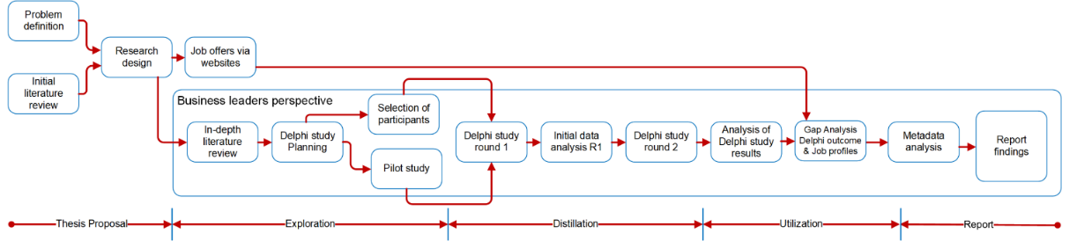
A quantitative content analysis was selected as the research method for analysing the collected job offers. The approach of using content published on websites is based on the public documents content research approach (Bryman & Bell, 2015, pp. 558-559).

The Delphi method is chosen because it offers the opportunity to draw together existing knowledge from a business leaders’ perspective efficiently, and it pinpoints areas of agreement or disagreement among experts. In addition, the Delphi method contains both elements of other research methods, such as qualitative and quantitative methods. By the nature of its procedural structure (to incorporate both qualitative [an expert group] and quantitative methods [surveys] to reach consensus), it allows the opportunity to achieve a more complete answer to the research question with a limited response group (Iqbal & Pipon-Young, 2009, p. 600).

The design of this Delphi study includes 15 participants for the response group. This is a realistic sizing since a relevant Delphi sample group consists of between 10 and 18 experts (Okoli & Pawlowski, 2004, p. 18). This Delphi study consist of two rounds. The initial round is for the expert’s opinion on the topics of soft skills and leadership for a CISO. The second round is meant for creating consensus on the topics and gives the experts the chance to revise their answers from the first round if they are persuaded by the answers of their peers.

Composition of the business leader response group

All responders are business leaders’ within a Dutch organisation with 500+ employees and therefore meeting the criteria of the Delphi responder
(see Table 1 for details). In the end both Delphi rounds consisted of 21 respondents distributed over seven different categories of business types, this corresponds to
21 organisations that have a CISO employed. The majority of the responders (71.5%, N = 21) have been in their role for more than six years and are familiar with soft skills.

Research taxonomy of Delphi design choices

For this Delphi study several design decisions were made which are presented in Table 1.

Criteria | Choices for Delphi study
Number of rounds | Two rounds  Reason: More than one round to align the opinions of business leaders
Response group | Business Leaders in Dutch organisation with 500+ employees
Expected saturation on response | Two rounds  Reason: Expected acceptance of results from previous Delphi round
Consensus in the Delphi study | Consensus is reached when 70% or more of the participants agree on statements in Round 1 or when the participants agree on the majority of their feedback in Round 2.  This is based on The Delphi Technique: Making Sense of Consensus by Hsu and Sandford (2007)
Consensus count in the Delphi study | The use of combined consensus is based on Börger (2012, p. 157), who stated that respondents using Likert scales tend to answer moderately and avoid extreme answers. Therefore, both positive answers (agree and strongly agree) are combined into one positive answer. A similar structure is used on the negative answers (disagree and strongly disagree).
Mode of operation | Remote survey  Reason: difficulty in planning the availability of business leaders to participate in a group debate
Anonymity | Anonymous  Reason: no need for personally identifiable information or opinions during analysis of data
Media | Electronic survey  Reason: ease of processing for participants and researchers
Validation of survey questions | Survey questions are validated using Gordon B Willis’ (1999) Question Appraisal System QAS-99 and with two test rounds.  Reason: QAS-99 provides a checklist for questionnaire preparation, and field testing for each survey round prevents unclear questions and research bias.
Socially desirable answers | The questions are structured based on a five-scale Likert question with the neutral answer in Position 3. With this construct, positive answers are in Positions 1 and 2, while negative answers are in Positions 4 and 5. Using this structure, we include both the socially desirable and the extreme answers of responders (Börger, 2012, p. 157).
Table 1: Delphi design choices

THE RESEARCH RESULTS AND INTERPRETATION

From the research, various discoveries were made about soft skills for the CISO in a leadership position. This section focuses on the soft skills found in the literature, an analysis of job offers and from the Delphi study.

Outcome of the CISO job ads – qualitative data analysis

A total of 77 CISO job ads were processed. Using the qualitative data analysis tool Atlas.ti, and according to the soft skills definitions by Robles (2012), the job descriptions were labelled. This analysis of the job ads provided insight into what organisations are seeking in the role of a CISO.
Many of the advertisements offered a clear description of hard skills, and some clearly listed the hard skills in bulleted lists. For example, the following skills were requested in a job ad:

- Contributes to the development of ING Bank security control frameworks and reference architectures based on (internal and external) threats identified
- Coordinates roll-out and monitors adherence to IT security standards and anti-fraud standards
- Supports security related audits
- Steers the operation of existing applications and services owned by security
- Reviews and approves risk acceptances/waivers from security perspective as a member of the risk committee. (ING, 2019)

Moreover, the certification in the field of CISOs were listed:

- Certified Information Systems Security Professional (CISSP)
- Certified Information Systems Auditor (CISA)
- Certified Information Security Manager (CISM)
- ISO27001/2 or equivalent (Gemeente Amsterdam, 2019).

In contrast, the soft skills in the job ads are less clear. The majority of job ads expressed the need for soft skills in descriptive sentences. After analysing the 77 job ads, writing and communicating stand out as two skills with a high degree of recognition. As an example, “Excellent written & spoken English is essential. Multiple languages preferred” (ING, 2019).

Data analysis using Atlas.ti provides information on the frequency or ‘groundedness’ of codes, meaning that it shows the number of quotations, or pieces of text, that are linked to a label. In the data analysis, the soft skills identified by Robles (2012) were used to label the described skills, and two extra skills were added (the label hard skill was added primary as an indicator of balance between hard skills and soft skills):
- Hard skills
- Leadership.

The hard skills were the top requested skills in the job ads. Figure 2 shows that the label hard skills is applied 547 times to the analysed job ads. The reality is that the number is much higher – during the labelling process, bulleted lists of hard skills were assigned one label, merely for use as an indicator of balance.

Figure 2 - Groundedness of soft skills and hard skills in job ads

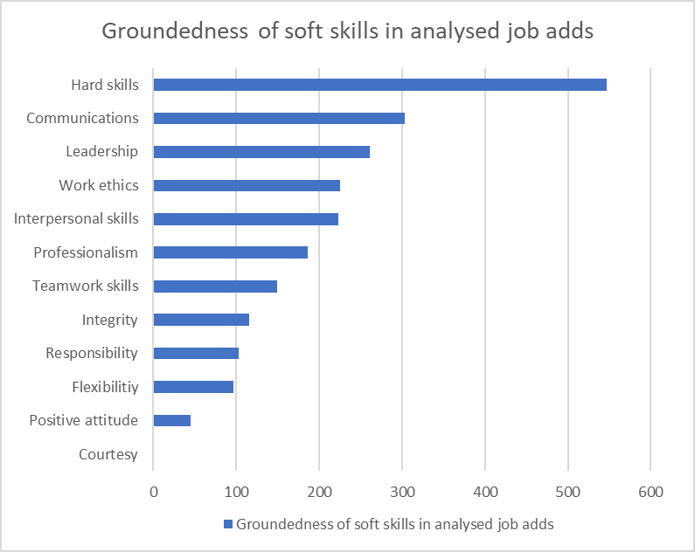

When this outcome is compared to the research of Hooper and McKissack (2016), their finding remains valid: the majority of the job advertisements place import on technical skills and daily operational tasks and have a strong focus on security (hard skills). Furthermore, our analysis of the required soft skills in job ads revealed that communication is the foremost needed soft skill based on the groundedness of codes. This is followed by leadership, work ethic and interpersonal skills. These three soft skills are closely matched in the number of described needs. One soft skill in particular draws our attention, namely, courtesy. Robles (2012) identified it as a soft skill; however, it was not found in any of the 77 analysed job ads. We could not find an academic explanation for this. Based on the feedback from the business leaders in this Delphi study, courtesy was the lowest ranked soft skill, and the generic explanation by CISOs is twofold:

- Courtesy is part of every soft skill
- Courtesy is not embedded in the Dutch (working) culture.

Figure 3 illustrates the focus on communication skills in the analysed job ads.

Figure 3 - Groundedness of soft skills in job ads

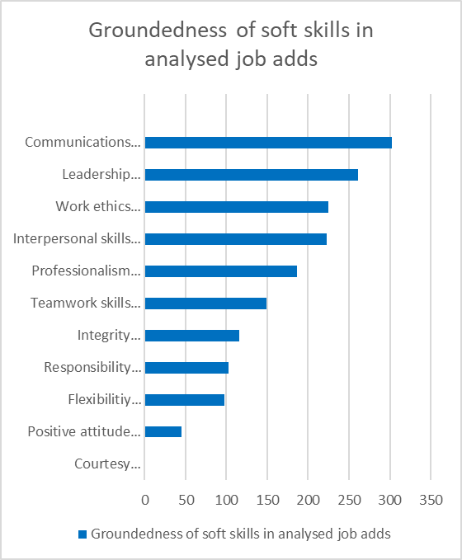

Outcome of the Delphi study – business leader response group
The first outcome is a confirmation that the business leader response group is familiar with soft skills (extremely familiar: 38.1%, N = 21; very familiar: 57.1%, N =21). None of the responders are unfamiliar with soft skills, as illustrated in Figure 4.

Figure 4 - Soft skill familiarity – business leader response group

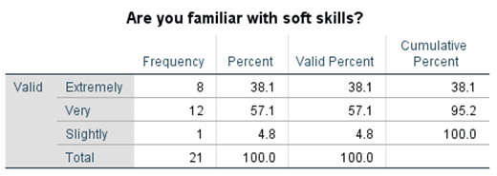

Soft skills for a CISO and the benefit of variations of soft skills in different organisations and audiences are valued as highly relevant in the business leader response group. The response group appreciated variations in the use of soft skills influencing different audiences and shared the observation of the positive effect of having soft skills and working with different audiences.
The five individual questions on the relevance of soft skills can be seen as one construct (Cronbach’s alpha is 0.89) and show a positive consensus (M = 1.83, SD = 0.85) that soft skills are relevant for a CISO. All questions were mandatory and had a score based on a five-point Likert scale. Furthermore, the business leader response group value a CISO’s use of soft skills that are relevant for the users in the organisation (76%, M = 2.24, SD = 0.889). This is valued higher compared to the other groups of Business Leaders of the IT department.

Dutch business leaders recognise the soft skills identified by Robles (2012); however, they have a different view on the ranking of the importance of the individual soft skills. The ranking, based on Round 1 of the Delphi study, is agreed, with a combined 81% consensus (9.5% strongly agree and 71.4% agree, M = 2.14, SD = 0.655). The business leader response group ranked the soft skill ‘courtesy’ in the lowest position. Table 2 presents the groups’ ranking of the soft skills.

Ranking: Soft skills confirmation – business leaders response group
Communication
Leadership
Interpersonal skills
Professionalism
Integrity
Responsibility
Positive attitude
Flexibility
Teamwork skills
Work ethic
Courtesy
Ranking is in order of importance. Top row is most important; bottom row is least important.
Note that the soft skill ‘leadership’ is not included in Robles’ (2012) overview.
Table 2: Soft skills confirmation – business leader response group

In Round 1 of the Delphi study, the question on soft skills was presented without the detailed soft skill attributes as shown in Table 2. This was deliberately done to avoid steering the responders’ thoughts on the completeness of the presented soft skills. The business leader response group added 21 additional soft skills when asked whether a soft skill was missing from the list identified by Robles (2012). In the second round, the added soft skills were returned to the business leaders to assess and validate them. Each of the additional soft skills was scored based on a five-point Likert scale. The results with a mean of 2.50 and higher were ignored (from moderately relevant and downwards), and this brings the total number of additional soft skills to 6 of the initial 21. Moreover, in reality, they are attributes of the soft skills determined by Robles (2012); see Table 3. The conclusion is thus that the Robles’ soft skills are a valid summary of soft skills.

Soft skill | Additional attribute
Communication | - Business sense (understand the business needs of the organisation) (1x)  - Being able to listen (1x)
Responsibility | - Accountability (1x)  - Results-driven (1x)
Work ethic | - Can-do mentality (1x)
Flexibility | - Responsiveness (1x)

Table 3: Additional soft skills – business leader response group

Findings of the meta-analysis

Merging the rankings of the soft skills from both response groups and the job ad analysis provides a combined overview of the required CISO soft skills and their overall ranking, as depicted in Table 4. The valuation is based on the mean of the ranking (position 1 = 11 points > position 11 – 1 point). The three individual rankings are valued equally. As expected, the top two skills are communication and leadership. Moreover, the soft skills ‘integrity’ and ‘work ethic’ are listed consecutively.

Ranking: Soft skills identified by Robles (2012) |  | Ranking: Soft skills found in analysed Job ads |  | Ranking: Soft skills confirmation – business leaders response group
Integrity |  | Communication |  | Communication
Communication |  | Leadership |  | Leadership
Courtesy |  | Work ethic |  | Interpersonal skills
Responsibility |  | Interpersonal skills |  | Professionalism
Interpersonal skills |  | Professionalism |  | Integrity
Positive attitude |  | Teamwork skills |  | Responsibility
Professionalism |  | Integrity |  | Positive attitude
Flexibility |  | Teamwork skills |  | Flexibility
Teamwork skills |  | Flexibility |  | Teamwork skills
Work ethic |  | Positive attitude |  | Work ethic
 |  | Courtesy |  | Courtesy
Legend: Ranking is in order of importance. Top row is most important; bottom row is least important.
Note that the soft skill ‘leadership’ is not included in Robles’ (2012) overview.
Similar ranking  BL & Job Ads  BL & Robles  Job Ads & Robles | One-position difference  BL & Job Ads  BL & Robles  Job Ads & Robles |  | Significant difference  BL & Job Ads  BL & Robles  Job Ads & Robles |  | Adjusted valuation of individual soft skills ‘work ethic’ and ‘integrity’.

Table 4: Overview of Soft Skill rankings
Table 4 shows a different ranking of the soft skills in our study compared to the ranking by Robles (2012). The explanation for the difference is that Robles is a US-based researcher whose study was conducted in the US, where 45 students in a junior-level business communication class interviewed executives to list the 10 most important soft skills they wanted new employees to possess when hired for a position within their organisation (Robles, 2012, p. 454), and Dutch business leaders clearly have a different view on the valuation of the soft skills.

The business leaders’ responses suggest a significant correlation between soft skills and leadership (r = .664, p = .001). This confirms that there is a relation between soft-skill relevance and leadership. The same relationship can be found between soft-skill relevance and recruitment (r = .667, p = .001).
It is expected that the rankings of the soft skills found in the analysed job ads and those confirmed by the business leaders response group would be closely aligned, since the business leaders constitute the demand side in the recruitment of a CISO. The responses in Round 1 of the Delphi study of the business leaders response group revealed that the group is moderately involved in the recruitment process (M = 3.38, SD = 1.72, N = 21), scored on a 5-point scale, where 1 = extremely, 2 = very, 3 = moderately, 4 = slightly and 5 = not at all. Analysing the responses in detail, we found that 10 out of 21 responders are not involved in the recruitment of the CISO. Therefore, the difference in alignment between the soft skill rankings based on the job ads analysis and those by the business leaders response group can be explained as follows: 43% of the business leaders are involved and 48% are not involved in the CISO recruitment. Although the response group is divided on participating in the actual recruitment process, this does not mean that their opinion on soft skills and CISOs can be ignored as the relationship between soft-skill relevance and recruitment (r = .667, p = .001) is significant; they are still demanding behavioural patterns from their CISOs.

The business leader’s response group (N =21) would prioritise soft skills in the recruitment phase by hiring a candidate with soft skills above one with the best-fitting hard skills.

Figure 5 - 67% of the business leaders will choose the candidate with developed soft skills over hard skills
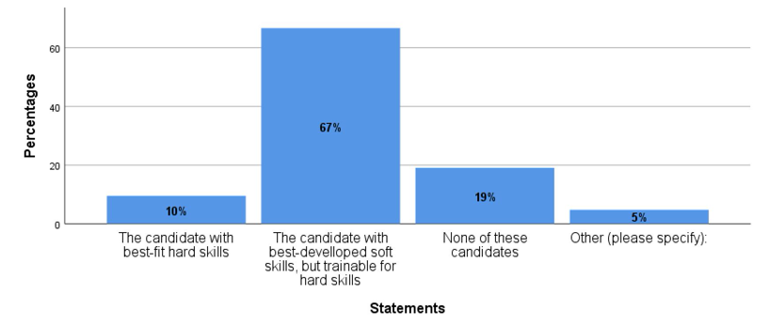

DISCUSSION AND CONCLUSION

Combining the literature study, the outcome of the job ad analysis and the findings from the Delphi studies adds to the relevance of soft skills for a CISO by the view of the business leader. The study shows that soft skills are relevant for the CISO to be effective. The following soft skills that positively influence the CISO leadership role were found from the literature, the response group, and the job ads (ranked in order of importance):

- Communication
- Leadership
- Interpersonal skills
- Professionalism
- Integrity
- Work ethics
- Responsibility
- Teamwork skills
- Positive attitude
- Flexibility
- Courtesy

The ordering of soft skills based on the job ads and the business leader response group has the similar ordering in the research of the soft skills by the CISO. In this similar study the participants are CISO's employed in a Dutch organisation with 500 or more employees as researched by Van Yperen et al. (2021, p. 475)

It is striking that the business leader response group view Robles’ soft skills as complete. The order of importance differs for the Dutch business leaders compared to Robles, which can possibly be explained by the cultural differences between the Netherlands and the US. The difference in the ranking confirms Chimatti's (2016) finding that the context of soft skills is essential, and location is a context that influences the sequence of and need for soft skills. Also the absents of the soft skill courtesy in the analysed job ads and the positioning of courtesy as last in the list of soft skills for the CISO by the business leaders starts a discussion on the value of the soft skill courtesy. The discussion could be if courtesy is embedded in all soft skills or does Dutch society assume courtesy as a given. This result is not part of this study and can be researched in the future.

Business leaders are demanding behavioural patterns from their CISOs, but only 43% is involved in the recruitment phase of their CISO. So, it is our conclusion that Business leaders should actively participate in the recruitment phase for the best fit CISO as a member in their leadership team.

Practical implications
The main goal of this study was to add academic evidence on the soft skills that positively influence the CISO leadership position in Dutch organisations with more than 500 employees. Input from Dutch business leaders and an analysis of job ads revealed that CISO job descriptions could be better detailed in terms of which soft skills are needed in the role and which ones are relevant for each specific organisation. Better job descriptions will lead to better alignment between skills and the demand of the business.

Moreover, based on the finding that soft skills are highly relevant, educational systems, personal development frameworks and recruitment can be further developed to focus on these much-needed soft skills. This practical implication means that testing of soft skills must be a significant part of the recruitment process.

Limitations
In our research, the limitation is the Dutch business leader population. We found a significant difference in the populations’ ranking of the soft skills identified by Robles. (2012). Therefore, it would of interest to benchmark the outcome across Europe and even globally.

Future research
Finally, further work is necessary to deepen the insights gained so far. Future research is advised on how the soft skills needed in everyday jobs and those needed for a specific organisation can be listed in job ads in an effective way. This could be for CISOs specifically or for wider, generic role descriptions.

As described in the discussions, future research could be the analysis of the difference between the US bases outcome of the soft skills, that include courtesy and the outcome of the Dutch based research that almost excludes the soft skill courtesy. Is Courtesy embedded in the Dutch Culture, is courtesy not relevant or is it a given.

Future research could include the wider European CISO and business leader population to explore the difference in soft-skill rankings in other European countries. Studies could also investigate how CISOs develop soft skills that are in demand by organisations.

The business leaders’ views on the soft skills ‘work ethic’ and ‘integrity’ are different. Future research could review whether integrity is a subset of work ethic, or vice versa, for a CISO role.

REFERENCES

B.Willis, G., & Lessler, J. T. (1999). Question Appraisal System QAS-99. Researchgate, 1-86.
Börger, T. (2012). Social desirablility and environmental valuation. Frankfurt am Main: Peter Lang.
Bryman, A., & Bell, E. (2015). Business Research Methods. New York: Oxford University Press.
Chimatti, B. (2016). Definition, development, assessment of soft skills and their role for the quality of organizations and enterprises. International Journal for Quality Research v10 n1, 97-130.
Council of the European Union. (2016, April 6). Directive 95/46/EC General Data Protection Regulation. Directive 95/46/EC General Data Protection Regulation. Brussels: Council of the European Union.
Death, D. (2019, February 18). Security Current Resources. Opgehaald van Security Current: https://securitycurrent.com/must-have-skills-for-cisos-a-cisos-connect-report/
ENISA. (2019, January 28). ENISA Publications. Opgehaald van ENISA: https://www.enisa.europa.eu/publications/enisa-threat-landscape-report-2018
Gemeente Amsterdam. (2019, 04 28). Stepstone. Opgehaald van Stepstone: stepstone.nl
Hayslip, G. (2019, May 5). CISO Manifesto: Recruiting CISOs not Unicorns. Opgehaald van Peerlyst: https://www.peerlyst.com/posts/ciso-manifesto-recruiting-cisos-not-unicorns-gary-hayslip-cissp-cisa-crisc-ccsk?utm_source=peerlyst_perspective&utm_medium=email&utm_content=peerlyst_post&utm_campaign=top_posts_on_peerlyst_this_week_05142019
Hooper, V., & McKissack, J. (2016, November - December). The emerging role of the CISO. Elsevier Business Horizons, pp. 585-591.
Hsu, C.-C., & Sandford, B. A. (2007). The Delphi Technique: Making Sense Of Consensus. Practical Assessment, Research & Evaluation, 1-8.
IGguru Information Governance News & Community. (2019, March 12). IGguru News. Opgehaald van IGguru: https://igguru.net/2019/03/12/ciso-the-c-level-executive-missing-from-your-board/
Indeed.com. (2020, July 30). Work Ethic Skills: Top 8 Values to Develop. Opgehaald van Career development: https://www.indeed.com/career-advice/career-development/work-ethic-skills
ING. (2019, 04 28). Indeed. Opgehaald van Indeed: indeed.nl
Iqbal, S., & Pipon-Young, L. (2009, July). The Delphi method. The Psychologist, pp. 598-601.
Levy, E., Delaney, K., Hill, J., & Buckalew, L. (2019). Next-Generation IT Talent Strategies. Opgehaald van Connected Future: https://connectedfutures.cisco.com/report/next-generation-it-talent-strategies/
Okoli, C., & Pawlowski, S. D. (2004). The Delphi method as a research tool: An example, design considerations and applications. Information & Management, 15-29.
Putrus, R. (2019). The role of the CISO and the digital security landscape. ISACA Journal, 2, 22-29.
Robles, M. M. (2012). Executive perceptions of the top 10 soft skills needed in today's workplace. Business Communication Quarterly, 453-465.
The Open University. (2019, 05 18). information technology: a new era? . Opgehaald van OpenLearn: https://www.open.edu/openlearn/people-politics-law/politics-policy-people/sociology/information-technology-new-era/content-section-0?active-tab=description-tab
van Yperen Hagendoorn, J., Smit, R., Versteeg, P., & Ravesteijn, P. (2021). Soft Skills of the Chief Security Information Officer. 34th Bled eConference Proceedings - Digital Support from Crisis to Progressive Change. June 27-30 (pp. 467-480). Bled: Bled University.
Weishäupl, E., Yasasin, E., & Schryen, G. (2018). Information security investments: An exploratory multiple case study on decision-making, evaluation and learning. Elsevier Computers & Security, 807-823.
Zohrabi, M. (2013, Februari). Mixed Method Research: Instruments, Validity, Reliability and Reporting Findings . Theory and Practice in Language Studies, pp. 254-262.

