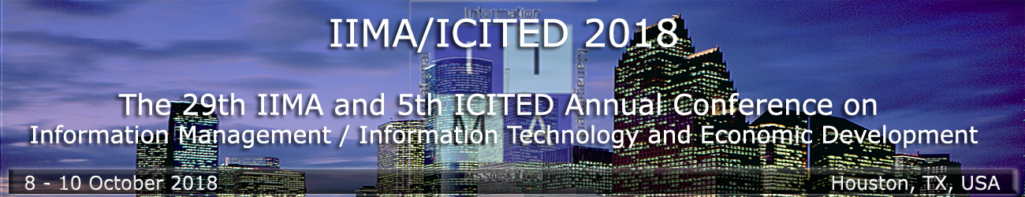
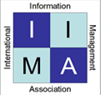

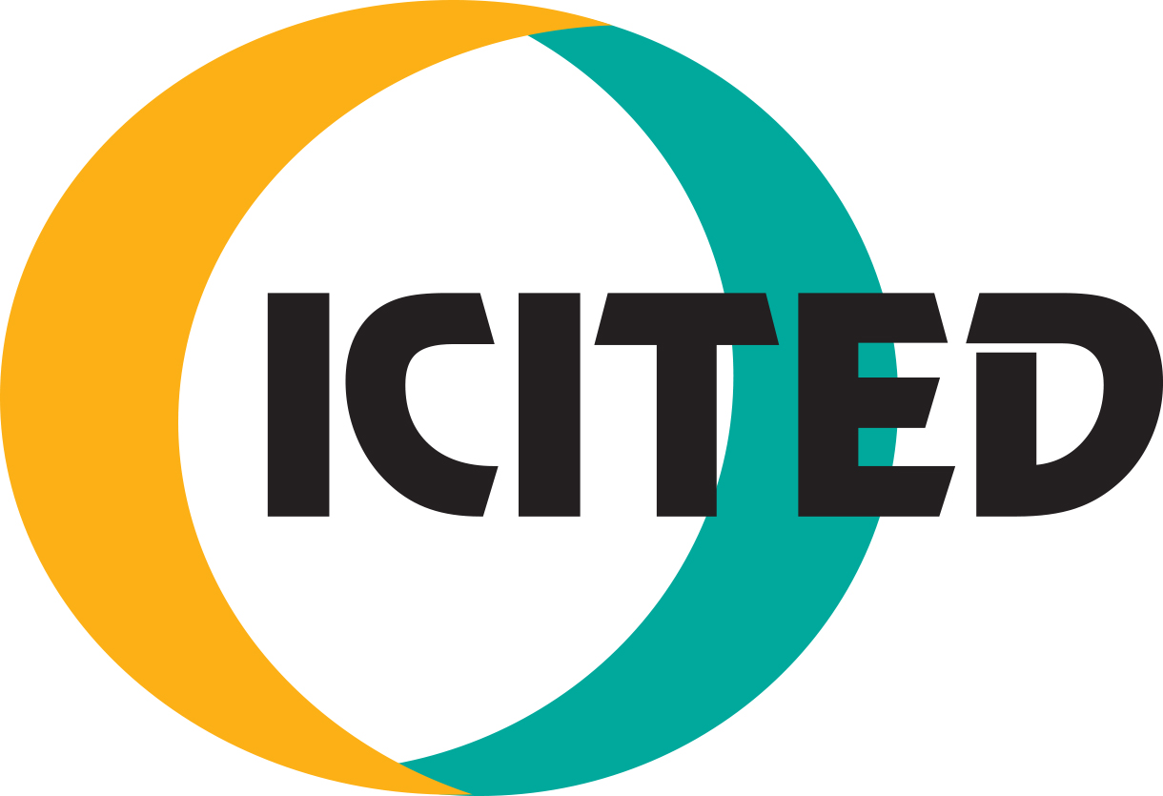
Call for Papers and Abstracts

29th Annual Conference of the
International Information Management Association (IIMA) www.iima.org

and the

5th Annual Conference of the
International Conference on Information Technology and Economic Development (ICITED)

Hosted by Prairie View A&M University www.pvamu.edu

Monday, October 8 – Wednesday, October 10, 2018

Theme: Securing the Internet and Cloud Technology:
Where Cutting-Edge Science meets Business

The second joint conference of the IIMA and ICITED organizations aims to promote the dynamic exchange of ideas among leading researchers, educators, developers and practitioners who share their research and disseminate innovations in education, business, and government. This conference is devoted to presenting and examining how information technology is aiding modern society to tackle complex problems in a smart way. Come, join and share with us in Houston, Texas.

Conference topics include but are not limited to: Cybersecurity, Medical Informatics, Smart Systems, E-learning, Library Science, IT for Economic Development, E- Government, Technological Innovations, Digital Marketing, Business Analytics, Cloud Computing, E-business/commerce, Emerging Trends, Digital Accounting, Healthcare IT, IT Auditing/Forensics, Mobile Computing, Organizational Culture & Technology, Social Networking, and Big Data.

You may submit a full paper (maximum 20 pages), a short paper (maximum 5 pages) or an abstract / work-in- progress (maximum 1 page).

Submission of Full Paper / Short Paper / Abstract or Work-in-Progress:
Submissions to IIMA/ICITED 2018 must not already have been published in a journal, presented at another conference, or be currently under consideration for publication or presentation elsewhere. All submissions will be reviewed by the track chairs, program committee and selected reviewers. All reviews are double blind. The editorial board will make the final determination whether the accepted papers are published in the conference proceedings. Exceptional papers will be referred for publication to one of the following journals:
- Communications of the IIMA (CIIMA) ISSN: 1941-6687 (http://scholarworks.lib.csusb.edu/ciima/)
- Journal of International Technology and Information Management (JITIM) ISSN: 1941-6679
(http://scholarworks.lib.csusb.edu/jitim/)

Papers should follow the style recommended by the American Psychological Associations (APA) Publication Manual. The language of the conference and related publications is English. Each accepted paper/abstract must be presented at the conference and be accompanied by paid registration.

Submissions to IIMA/ICITED 2018 Please submit an electronic copy through the Easy Chair program at www.iima.org (Click on IIMA 2018 and then click Submit or go directly to https://easychair.org/conferences/?conf=iimaicited2018 ) no later than June 1, 2018. Any submission that is received after the deadline, exceeds length requirements, or does not adhere to the format will be rejected without review.

Submission Panel or Workshop
The conference will feature sessions on topics of special interest. To propose a panel, contact the program chair and provide the session topic and a list of 3-5 potential panelists. To propose a workshop, contact the program chair with a short description of the proposed workshop.

Submission Deadline: June 1, 2018
Conference Acceptance Notification: July 1, 2018
Final Version Due: August 1, 2018
For more information: Visit the IIMA website: www.iima.org

Conference Chair: Emmanuel U. Opara: Prairie View A&M University: euopara@pvamu.edu
Program Chair: Jaymeen Shah, Texas State University: jaymeen.shah@txstate.edu
Co-Program Chair: Abel Usoro, University of the West of Scotland: abel.usoro@uws.ac.uk
Co-Program Chair: Louis Ngamassi, Prairie View A&M University: longamassi@pvamu.edu

